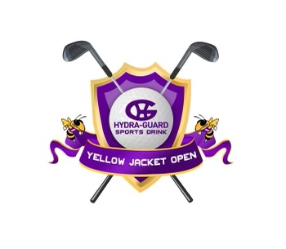
2022 Hydra-guard Yellow Jackets Open Entry Form

The 18 holes Iowa High Open will be held Thursday, April 7th, 2022 at Kosati Pines Golf Course in Kinder, LA. The tournament will be tee time start at 11 a.m.
Entry Fees
$250 for a Boys Team (5 players)
$150 for a Girls Team (3 players)
$50 for an Individual.
*Casino rate has gone up for 2021
The entry fee will cover green fees, range balls, a meal and a t-shirt for each player
*If teams are interested in a practice round, please contact Kosati Pines @ (337) 738-4777 to schedule a time. However, please note: Practice Rounds are not included in entry fees!
* if you would like to book a hotel rooms, they advised us to do so ASAP to get a great hotel rate
Carts will be available for all coaches. Parents and spectators will be able to rent a cart if additional carts are available.
Prizes
1st place team plaques for Boys and Girls Team
Medals for the top boy and girl individual
Hydra-guard Yellow Jacket Open Golf Tournament

Interested teams should email the follow to blake.reynolds@cpsb.org : as soon as possible
- School Name
- Coaches Name
- Coaches Cell Phone Number
- Player Names, Average score for 18 holes, & T Shirt Sizes

Deadline to enter is March 22 – this will help with pairings
*Email me your T-Shirt Sizes ASAP.
Complete the entry form below and submit your entry fee
Mail payments to: Iowa High School
401 W. Miller Ave.
Iowa, La 70647
Phone: 337-217-4380
Fax: 337-217-4381

For more information or questions, Contact Blake Reynolds @ (337) 884-1651

Please Print Information Clearly
School - ____________________________________________

Coach - ____________________________________________

Shirt Size - _________________________________________

Phone - ___________________________________________

E-mail - ___________________________________________
Hydra-guard Yellow Jacket Open Golf Tournament

Boy’s Team
A Team
Player 1 _________________________Avg. _____ T-Shirt Size ______
Player 2 _________________________Avg. _____ T-Shirt Size ______
Player 3 _________________________Avg. _____ T-Shirt Size ______
Player 4 _________________________Avg. _____ T-Shirt Size ______
Player 5 _________________________Avg. _____ T-Shirt Size ______

B Team/Individual
Player 1 ________________________Avg. _____ T-Shirt Size ______
Player 2 ________________________Avg. _____ T-Shirt Size ______
Player 3 ________________________Avg. _____ T-Shirt Size ______
Player 4 ________________________Avg. _____ T-Shirt Size ______
Player 5 ________________________Avg. _____ T-Shirt Size ______

Girl’s Team
Player 1 _________________________Avg. _____ T-Shirt Size ______
Player 2 _________________________Avg. _____ T-Shirt Size ______
Player 3 _________________________Avg. _____ T-Shirt Size ______

Girl’s Individual
Player 1 ___________________ Avg._______ T-Shirt Size ______
Player 2____________________ Avg. _______ T-Shirt Size ______

