February 1, 2022 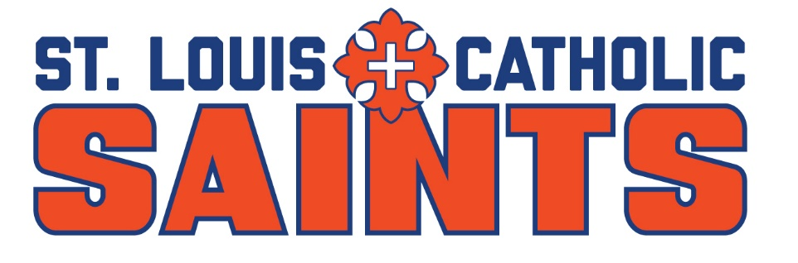

Dear Coach,

The dates for the 17th annual St. Louis Catholic High School Invitational tournament are Monday, March 14, and Tuesday, March 15, 2021. This unique high school event will be played at Lake Charles CC and the brand new Mallard Golf Club. Entry fee is $100 per player, which covers both rounds and a meal each day.

In an effort to increase the quality of our field, we are inviting the top finishers in all classes of last year’s state tournaments – both boys and girls. Please indicate below whether or not your team plans on participating in this year’s event. Special room rates can be arranged if demand warrants.

If you have any questions, please call Pat Neck at 337-794-4049. Your prompt attention is greatly appreciated.

Regards,

Pat Neck
Head Golf Coach/Athletic Director
St. Louis Catholic High School

Dave Kaspar
Tournament Director

Email your response, lineup, and shirt sizes to pneck@slchs.org by February 28, 2021.

School Name:

Contact Person:

Contact Number: School Cell

*****All Future Correspondence Will Be By Email*****
Email Address:

Yes, we plan on playing No, we cannot play

If playing, please circle one: BOYS ONLY GIRLS ONLY BOTH

