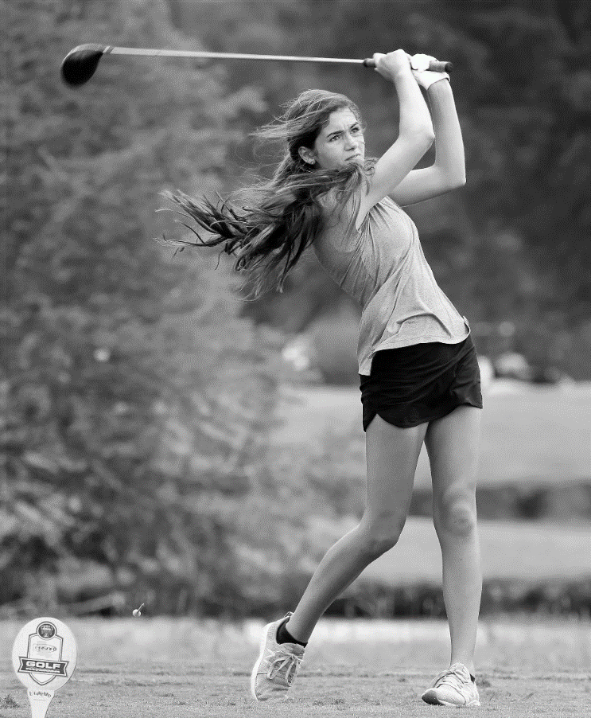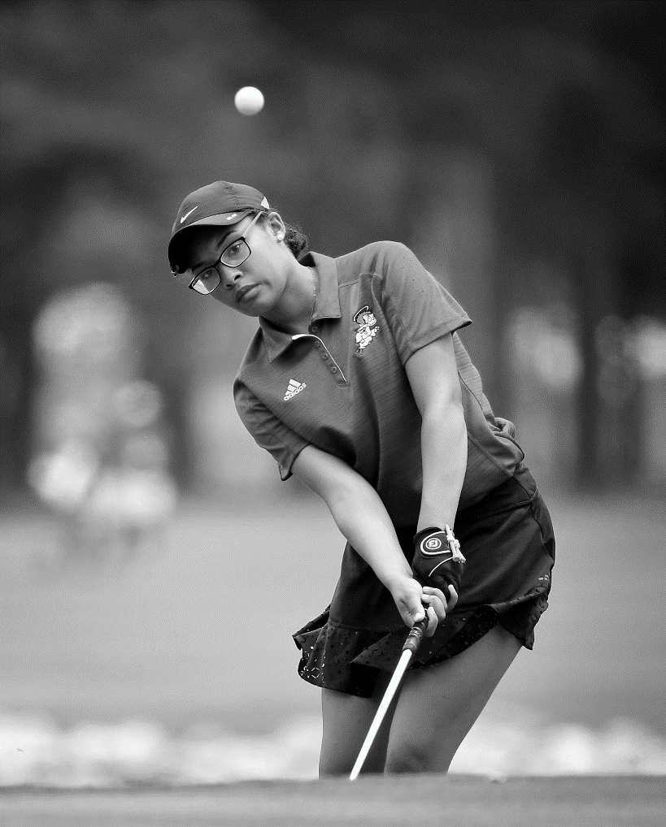

LOUISIANA HIGH SCHOOL ATHLETIC ASSOCIATION



**2024 LHSAA GIRLS GOLF**

*State Championship Bulletin*

**TABLE OF CONTENTS**

|  |  |
| --- | --- |
| **CONTENT** | ***PAGE(S)*** |
| STATE TOURNAMENT GENERAL INFORMATION | PAGES 3-5 |
| STATE TOURNAMENT COURSE INFORMATION | PAGE 6 |
| PRACTICE ROUND INFORMATION | PAGE 7 |
| LIVE SCORING INFORMATION | PAGE 8 |
| HOTEL INFORMATION | PAGE 9 |
| CHAMPIONSHIP SOUVENIRS | PAGE 10 |
| MAPS | PAGE 11 |

**STATE Tournament GENERAL INFORMATION**

|  |  |
| --- | --- |
| **CATEGORY** | **INFORMATION** |
| State Tournament Dates/Sites | The state tournament will be held April 29-30, 2024, at  Les Vieux Chenes. Divisions I and II will begin each day in a split tee format at 9:00am. |
| Qualifying for State | To participate in the state tournament, a golfer shall be a member of a team that qualifies to the state tournament from the regional tournament in her division, or she shall qualify as an individual medalist at the regional tournament.  *Definition of Team*: In girls’ play, in all divisions, a maximum of three golfers may be entered into a regional or state tournament. The two lowest legal scores recorded, each day by the team’s golfers, shall be totaled to determine the team score.  *Definition of Medalist*: A medalist may be a member of an official LHSAA team or an individual golfer from a school that does not have enough golfers entered into the state tournament to field a team. |
| Pairings and Tee Times | Please note that NO pairings and tee times for the LHSAA Boys’ and Girls’ Golf Tournaments will be made public and posted until **ALL 12** regional events have been completed and scores have been reported. The final regional tournament is scheduled for Tuesday, April 23. We anticipate that pairings and tee times for all both tournaments will hopefully be available before Thursday evening, April 25. Pairings do not get issued sooner because you ask. Appreciate your patience! |
| State Tournament Withdrawals | If a school or individual medalist that qualifies for the state golf tournament wishes to withdraw, the school’s principal SHALL submit a signed statement to the LHSAA Executive Director requesting not to be entered into the tournament ASAP after the completion of the regional tournament. If properly notified within the 24-hour deadline, the team and/or individual player with the next lowest score from the same regional tournament may be substituted prior to the pairings being set. If a school fails to withdraw its team from the regional tournament after the pairings have been set and the team withdraws, forfeits, or fails to show up for the tournament, then the school may be fined $200. |
| State Tournament Format | The state tournament shall consist of two rounds of 18 holes for a 36-hole competition. |
| Inclement Weather | If competition is interrupted due to darkness, inclement weather, or any other valid reasons as approved by the tournament director/committee, if possible, the competition shall be completed the next day from the point of interruption.  If this is not possible, due to the availability of the course or other valid reason as approved by the tournament director/committee, if one round of 18 holes of play is cancelled because of inclement weather, the state championship shall be determined by the recorded scores after one 18-hole round. If a round of play is canceled because of inclement weather before all competitors have completed play on that day the entire round shall be:   1. Cancelled if this occurs on the first day of play. 2. Cancelled if this occurs on the second day of play and the first day of play has been completed. 3. Suspended if this occurs on the second day of play and the first day of play has been cancelled because of inclement weather and shall be completed on the next playable day that is approved by the Executive Director. 4. If one 18-hole round of play is completed on either day one or day two and every player in the competition completed the same nine holes on the other day of competition, then those nine holes will be computed into the team and individual scores to get a 27-hole total recorded to determine the state champion. |
| State Tournament Fees | Each school is responsible for all green fees, practice rounds, and range ball fees. ***Make ALL payments to the course on the FIRST DAY of tournament in ONE payment per school AFTER the coaches meeting***. The pro shop will not be set up to handle payments until after the coaches meeting. Fees shall be made payable by SCHOOL check/money order, exact cash, or credit card. Let’s make sure the course is not tracking anyone down for payment – thank you!  **Girls @ Les Vieux Chenes**: Call on Sunday for practice round tee times Sunday $14 practice round to walk $5 small bucket ; $7.50 large bucket No spectator carts on Sunday due to public play  Monday $25 tournament fee per golfer Tuesday $25 tournament fee per golfer |
| State Tournament Rules | The United States Golf Association (USGA) Rules of Golf will govern the conduct of both the regional and state tournaments, except where modified by the LHSAA and/or local course rules approved by the tournament director/committee. Please familiarize yourself with both the USGA rules and the bylaws of the LHSAA handbook pertaining to Golf. |
| Carts | One complimentary cart will be provided on Monday & Tuesday to coaches who have qualifying teams or who have qualifying individuals. Carts will be available for rental by spectators at the discretion of each course. |
| Coaches Meeting | The MANDATORY coaches meeting for Divisions I and II is at 8:00am Monday at both courses. The golf pro/rules official will go over local rules & other course-specific info. Wristbands will be distributed before/after the coaches meeting. Head and Assistant Coaches MUST sign the sign-in sheet with the LHSAA host. If a coach will not be present, he/she must have a signed agreement with another school to serve as your golfer’s coach OR a registered coach in the LHSAA system will serve as coach. |

**STATE Tournament COURSE INFORMATION**

|  |  |  |  |
| --- | --- | --- | --- |
| **DIVISION I** | | | |
| **TOURNAMENT DIRECTOR** | **COURSE** | **DATES** | **TIMES** |
| Todd Robertson (Pro) Ruthie Dugal (LHSAA Rep) | Les Vieux Chenes | April 29-30 | Monday: Report Time 8:00 am  Monday: Tee Time 9:00 am  Tuesday: Tee Time 9:00 am |
| **DIVISION II** | | | |
| **TOURNAMENT DIRECTOR** | **COURSE** | **DATES** | **TIMES** |
| Todd Robertson (Pro)  Ruthie Dugal (LHSAA Rep) | Les Vieux Chenes | April 29-30 | Monday: Report Time 8:00 am  Monday: Tee Time 9:00 am  Tuesday: Tee Time 9:00 am |

***Golfers will use the split tee format on both days!***

COMPLIMENTARY BOTTLED WATER WILL BE AVAILABLE FOR PLAYERS & COACHES AT HOLES #1 & #10.

SPECTATORS SHOULD USE EACH COURSE’S RESTAURANT/SNACK BAR FOR REFRESHMENTS.

**practice round information**

Practice rounds on Sunday, April 28th, must be scheduled with the course in advance and paid for on site. Practice rounds prior to April 28th will be at the discretion and availability of the golf course. Only qualified team members are allowed to play on Sunday afternoon at the discounted rate.

Please contact the course in advance for practice round information on Sunday.

**Les Vieux Chenes   
All Divisions-Girls**340 Old Youngsville Highway, Youngsville, LACall 337-837-1159, pro shop to schedule 48 hours in advance$14 per player (walk) – NO carts on Sunday due to course being open for public play  
Range Balls - $5 for small, $7.50 for large

**LIVE SCORING information**

GOLF GENIUS will be the digital scoring app used by golfers on their cell phones to record scores and for spectators to follow. Below are scorecard and viewing instructions.

CTRL + CLICK to follow the LINKS below.

[DIGITAL SCORECARD INSTRUCTIONS](https://files.constantcontact.com/dddb7521801/8f669c4d-3c52-4b1f-ac6d-bc7116dcfdd4.pdf?rdr=true)

This is for the players and has instructions on how digital scorecards work in the Golf Genius environment. There is a link in the document that will take the players to an instructional video for accessing and using digital scorecards. The document also shows the instructions in printed form. Along with the link to the instructional video, there are also links on the Apple App Store and Google Play Store logos that will take the player to the appropriate application to download the Golf Genius app if the player doesn't have the app already.

[LIVE SCORING - VIEWING INSTRUCTIONS](https://files.constantcontact.com/dddb7521801/da5abeb3-8bf1-4647-8404-c1daeac6143b.pdf?rdr=true)

This document is for spectators/parents. It has active links on the Apple and Google logos that will take them directly to the Golf Genius app for downloading. It also contains the GGID codes to use for accessing the live scoring for each of the six tournaments.

**HOTEL information**

**The following are “sponsoring” hotels for the state golf tournament.   
Coaches are encouraged to use these properties if possible:**

DoubleTree by Hilton Lafayette 1521 W. Pinhook Rd. Justin Doucet (337) 235-6111 [justin.doucet@hilton.com](mailto:justin.doucet@hilton.com)

Drury Inn & Suites 120 Alcide Dominique Dr. Emily Skinner (337) 262-0202 [Emily.Skinner@DruryHotels.com](mailto:Emily.Skinner@DruryHotels.com)

Hampton Inn Broussard 2280 E. Main St. Brittany Perry (337) 330-2500 [bperry@divihospitality.com](mailto:bperry@divihospitality.com)

Hilton Garden Inn-Lafayette Cajundome 2350 W. Congress St. Hilton Sales Team (337) 291-1977  
[lftcd-salesadm@hilton.com](mailto:lftcd-salesadm@hilton.com)

La Quinta Inn & Suites-Broussard 104 Sweetland Dr. Brittany Perry (337) 330-8081 [bperry@divihospitality.com](mailto:bperry@divihospitality.com)

PLEASE CONTACT THESE HOTELS AS SOON AS POSSIBLE AFTER QUALIFYING FOR THE STATE TOURNAMENT

**championship souvenirs**

|  |  |
| --- | --- |
| **CHAMPIONSHIP APPAREL** | Remember this achievement. Visit the PepWear Store or shop.lhsaa.org to purchase Official Event Merchandise including shirts and hoodies with participants’ names on the back, full color plaques, and more!  For assistance with orders contact (866) 775-3450 or [customerservice@pepwear.com](mailto:customerservice@pepwear.com) |
| **Championship photographs**  Geaux Preps Home Page - GeauxPreps | GeauxPreps is the digital partner of the LHSAA. Browse their digital collection of photos that encapsulate the thrill and passion of high school sports. Visit the link below to purchase photos of your favorite athlete during tournament action!  [www.geauxpreps.com](http://www.geauxpreps.com)/photos |
| **Championship rings** | Congratulations champions! Celebrate your victory with your championship ring- the ultimate symbol of dedication, perseverance and teamwork. Herff Jones is proud to be the exclusive provider for LHSAA and LHSCA Championship Jewelry and is the recognized leader in celebrating student milestones.  Baton Rouge, LA // 225.927.1383 // [gshhbrla@gradsupply.biz](mailto:gshhbrla@gradsupply.biz)  Metairie, LA // 504.737.4439 // [gradsupply@aol.com](mailto:gradsupply@aol.com) |
| **Championship replica trophies** | For more information regarding State Championship mini replica trophies and medals, contact  Gold Star Trophies at (225) 928-4230.  [www.goldstartrophies.com](http://www.goldstartrophies.com) |

**LAFAYETTE AREA MAP**

