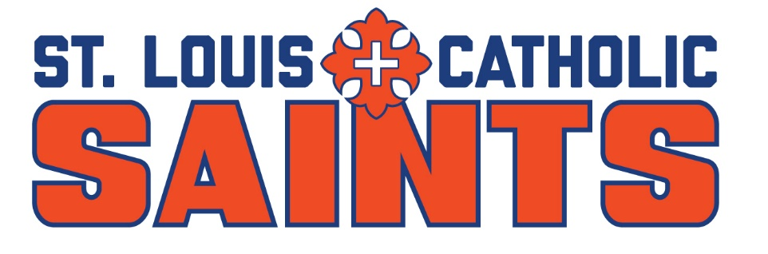

Dear Coach,

The dates for the 19th annual St. Louis Catholic High School Invitational tournament are Monday, March 25, and Tuesday, March 26, 2024. This unique high school event will be played at Lake Charles CC and the Contraband Bayou GC. Entry fee is $120 per player, which covers both rounds and a meal each day. Shotgun starts will be at 11 a.m. both days.

Regards,

Pat Neck
Head Golf Coach/Athletic Director
St. Louis Catholic High School

Email your response, lineup, and shirt sizes to pneck@slchs.org by February 29, 2024.

School Name:

Coach:

Contact Info: Email Cell

Yes, we plan on playing No, we cannot play

If playing, please circle one: BOYS ONLY GIRLS ONLY BOTH

Player 1 _______________________ Size_____

Player 2 _______________________ Size_____

Player 3 _______________________ Size_____

Player 4 _______________________ Size_____

Player 5 _______________________ Size_____

