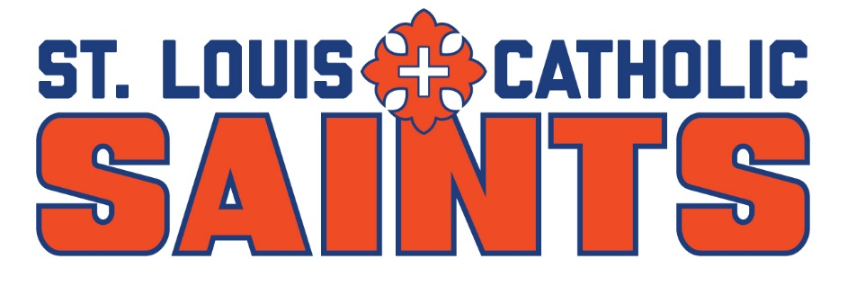
The 21st annual St. Louis Catholic High School Invitational tournament will be held Monday, April 6, and Tuesday, April 7, 2026. Both rounds will be played at The Lake Charles CC. Entry fee is $150 per player, which covers both rounds and a meal each day. Shotgun starts will be at noon on Monday and 8A on Tuesday.

Complete this page and mail it along with your payment of $150/player to:

Bob Anderson, Head Golf Coach, St. Louis Catholic High School
4801 E. Cypress Landing Dr., Lake Charles, LA 70605 #337-842-6000

Checks made out to: St. Louis Catholic, Memo: Golf

Email your response & lineup as soon as possible to todaysok@aol.com Entries close Feb 16th with checks due by March 1st.

School Name:

Coach:

Contact Info: Email Cell

If playing, please circle one: BOYS ONLY GIRLS ONLY (3) BOTH

Player 1 _______________________ Avg_____

Player 2 _______________________ Avg_____

Player 3 _______________________ Avg_____

Player 4 _______________________ Avg_____

Player 5 _______________________ Avg_____

Please Note: Preference will be given to COMPLETE A TEAMS, then INDIVIDUALS, then B TEAMS. If more than 5 players requested, copy this page or send a second page with the requested information. Registration is not a guarantee of tournament entry. Tournament committee will review all registrations and advise of acceptance.

