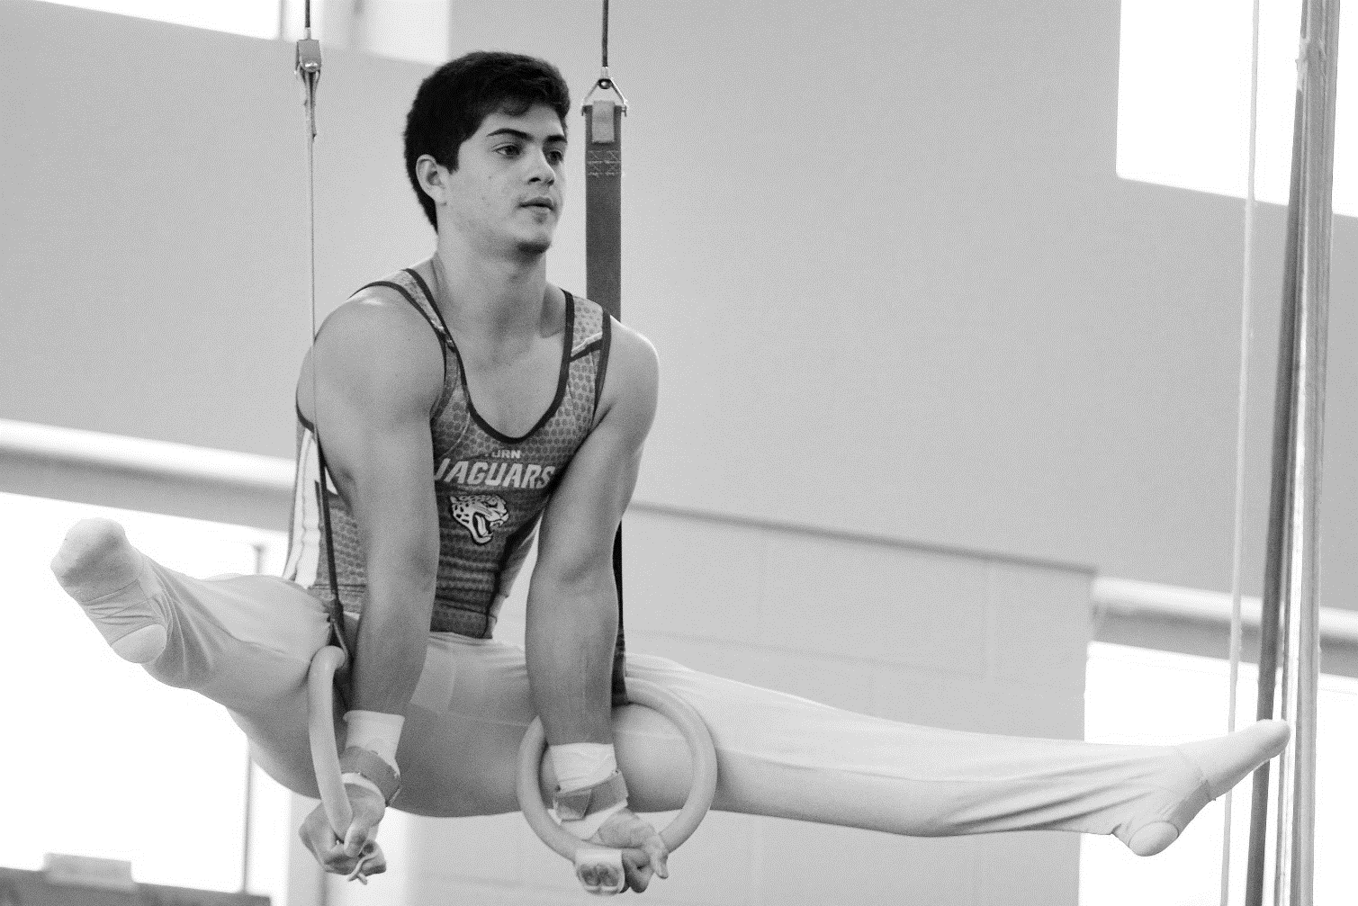
LOUISIANA HIGH SCHOOL ATHLETIC ASSOCIATION AAASSOCIATION

2024 LHSAA
BOYS’ GYMNASTICS
State Championship Bulletin

boys’ gymnastics state meet
General information

CHAMPIONSHIP INFORMATION
Friday, April 12, 2024
Baton Rouge Magnet High School
Tournament Director | Kristen Estorge, Baton Rouge Magnet High School
LHSAA Director | Lee Sanders
2023-24 USAG Rules will be followed
ENTRY BLANKS
Entry blanks must be sent by certified mail to Kristen Estorge with a postmarked date of Monday, March 25, 2024.

The entry blank must be accompanied by a school check made payable to the LHSAA in the amount of $20 per student entered.

Mail to:
Kristen Estorge, Gymnastics Meet Director
Baton Rouge Magnet High School
2825 Government St | Baton Rouge, LA 70806

USAG COMPLIANCE
The meet director of the host school will be responsible for securing regulation USAG-approved equipment and such officials, scorers and other attendants as necessary for conducting the meet.

COACHES PROTOCOL
A coach will be allowed to submit as many names as he or she desires on the entry blank in each event in the "compulsories" and in each event in the "optionals". All contestants must meet all LHSAA eligibility requirements.

Substitutions or additions after the deadline will not be permitted. If a contestant is ill, injured or unable to compete for any reason, he will be withdrawn from competition without a replacement.

Except in a situation like the bullet point below, a school representative must be present at the coaches' meeting or that school's contestants will not be allowed to participate. The time of the coaches' meeting will be set by the meet director.
In order to compete, a team with three (3) or more individuals must be accompanied by a faculty member of its school or a certified Non-Faculty coach. By written mutual agreement two schools in the same area, one school sending three (3) or more individuals to any meet and the other school sending only one (l) or two (2) individuals, may choose a representative from either school to accompany these participants to any high school meet.

The conduct of coaches will be governed under the provision of the USAG.
UNIFORMS
In order to meet the uniform requirements, contestants must be dressed in sleeveless competition singlets (tank top style) and gymnastic form pants. Gymnastic (close fitting) trunks will be permissible ONLY IN THE FLOOR EXERCISE AND IN VAULTING.
PROTESTS
In accordance with USAG guidelines, no protest will be allowed. Judges will discuss routines with coaches after the meet only.
PENALTIES
If the provisions of the Entry Blank Deadline and/or Certifications of Coaches are not met, the school and its contestants may be allowed to enter and compete in the tournament by paying a $50 fine for one individual competition or a $100 fine for two or more competitors. The deadline for paying the delinquent fee in order to participate shall be 48 hours prior to the start of the first day of the meet. (Rule 16.3.7, page 135 of the LHSAA Handbook)

ADMISSION
The admission charges for each session will be as follows:
  - Students - $5.00 | Adults - $10.00

DIVISIONS

DIVISION OVERVIEW
Gymnasts will compete in only one (1) division in either “compulsories” or “optionals” and may enter the following events:
  - Floor Exercise
  - Pommel Horse
  - Still Rings
  - Vault
  - Parallel Bars
  - Horizontal Bars

All six (6) events will be conducted at USAG Level 4 for compulsories.

Level 10 Rules will be followed for the “optionals” in each event.

Schools shall have unlimited entries per event.

Only the scores of the top three (3) gymnasts in each event will count toward their team score.

DIVISION I
In Division I, optionals, the team score will be determined by adding together the top three individual scores for each team from each of the six events. Awards will be given to the team members of the Division I champion team and to the team members of the Division I runner up team. Awards will also be given to the first, second, and third place "all around" gymnasts and the first, second and third place winners in each event in Division I.
DIVISION II
In Division II, compulsories, the team score will be determined by adding together the top three individual scores for each team from each of the six events. Awards will be given to team members of the Division II champion team and to the team members of the Division II runner up team. Awards will also be given to the first, second, and third place winners in each event in Division II, as well, as the first, second, and third place "All Around" gymnasts in Division II.
DETERMINING OVERALL SCORES
In order to determine overall team scores, the Division I and Division II team scores for each team will be added together. Team trophies will be presented to the "overall championship team" and to the "overall runner-up team". Individual awards will be presented to the members of the "overall championship and runner-up teams.”

BOYS’ DIV. I GYMNASTICS ENTRY FORM

Deadline: Monday, March 25, 2024 (Postmarked)

Entries should not be sent to the LHSAA. Send by certified mail to Kristen Estorge, Baton Rouge Magnet High School, Baton Rouge, LA 70806

Each entry must be accompanied with a school check made payable to the LHSAA in the amount of $20 per student entered.

Schools shall have unlimited entries per event.

School Name
Coach Name
Coach Email
Coach Signature
Principal Signature
Date

DIVISION I OPTIONALS
1. | 11.
2. | 12.
3. | 13.
4. | 14.
5. | 15.
6. | 16.
7. | 17.
8. | 18.
9. | 19.
10. | 20.

BOYS’ DIV. II GYMNASTICS ENTRY FORM

Deadline: Monday, March 25, 2024 (Postmarked)

Entries should not be sent to the LHSAA. Send by certified mail to Kristen Estorge, Baton Rouge Magnet High School, Baton Rouge, LA 70806

Each entry must be accompanied with a school check made payable to the LHSAA in the amount of $20 per student entered.

Schools shall have unlimited entries per event.

School Name
Coach Name
Coach Email
Coach Signature
Principal Signature
Date

DIVISION II COMPULSORIES
1. | 11.
2. | 12.
3. | 13.
4. | 14.
5. | 15.
6. | 16.
7. | 17.
8. | 18.
9. | 19.
10. | 20.

boys’ gymnastics state meet
TENTATIVE SCHEDULE

FRIDAY, APRIL 12, 2024
ALL BOYS
ALL DIVISIONS
1:45 PM | STRETCH
2:00 PM | WARM-UPS/ COMPETITION
5:30 PM | AWARDS
6:00 PM | GYM CLOSES

media/school yearbook

(Please read the LHSAA Media Policy found on the LHSAA Website)
MEDIA
Request media credentials online by visiting the Media Credential link on the LHSAA website. You can find the link to the credential application at lhsaa.org -> News & Media -> Media Resources -> 2024 Media Credential Application. For further assistance, contact Vincent Cacioppo, LHSAA Director of Communication at vcacioppo@lhsaa.org.

Photos taken during an event may not be sold or used in any capacity outside of the purpose(s) of their school’s yearbook and/or newspaper. The LHSAA has an exclusive photography contract with RomaPics.

RADIO BROADCASTING
The fee per game is $150 with included LHSAA Sponsor Reads

