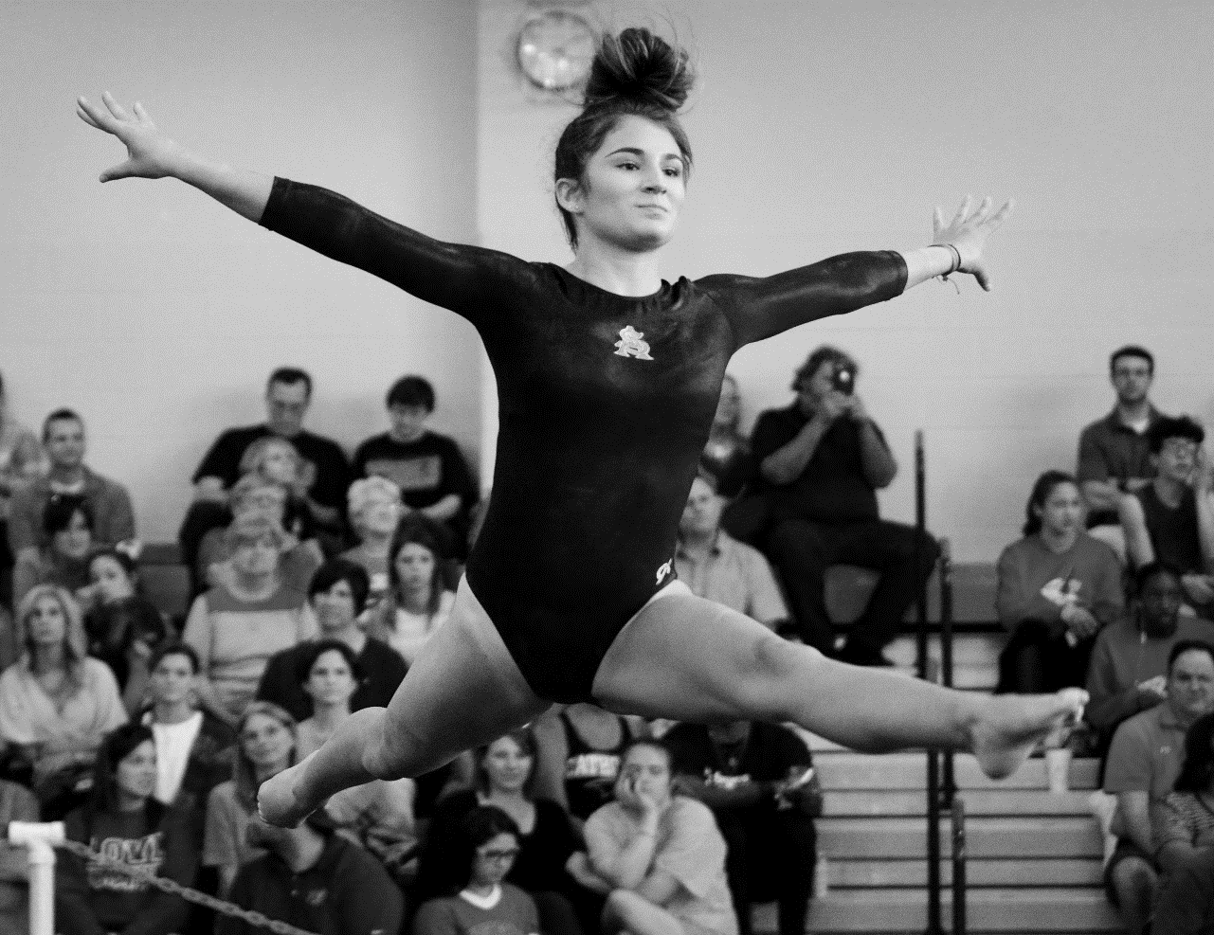
LOUISIANA HIGH SCHOOL ATHLETIC ASSOCIATION

2024 LHSAA
GIRLS’ GYMNASTICS
State Championship Bulletin

GIRLs’ gymnastics state meet
General information

CHAMPIONSHIP INFORMATION
Saturday, April 13, 2024
Baton Rouge Magnet High School
Tournament Director | Kristen Estorge, Baton Rouge Magnet High School
LHSAA Director | Lee Sanders
ENTRY BLANKS
Entry blanks must be sent by certified mail to Kristen Estorge with a postmarked date no later than Monday, March 25, 2024.

The entry blank must be accompanied by a school check made payable to the LHSAA in the amount of $20 per student entered.

Mail to:
Kristen Estorge, Gymnastics Meet Director
Baton Rouge Magnet High School
2825 Government St | Baton Rouge, LA 70806

USAG COMPLIANCE
The meet director of the host school will be responsible for securing regulation USAG-approved equipment and such officials, scorers, and other attendants as necessary for conducting the meet. 2023-24 USAG Rules will be followed.

COACHES PROTOCOL
Coaches will be allowed to submit as many names as he/she desires on the school entry blank but contestants are limited to competition in only one division. All contestants must meet all LHSAA eligibility requirements.

Substitutions or additions after the deadline will not be permitted. If a contestant is ill, injured or unable to compete for any reason, she will be withdrawn from competition without a replacement.

Except in the case of the bullet point below, a school representative must be present at the coaches’ meeting or that school’s contestants will not be allowed to participate. The time of the coaches' meeting will be set by the meet director.

In order to compete, a team with three or more individuals must be accompanied by a faculty member of its school or a certified Non-Faculty coach. By mutual written agreement, two schools in the same area, one school sending three or more individuals and the other school sending one or two individuals, may choose one faculty representative from either school to accompany these participants to any high school meet.

The conduct of coaches will be governed under the provisions of the USAG.

UNIFORMS
In order to meet uniform requirements, contestants must be dressed in leotards. Ankle length tights may be worn under OR over the leotard (that match the leotard or are skin tone). Shorts MUST be solid black with no embellishments and worn over leotard and the length must be above the knee or shorter.
PROTESTS
Inquiries may be made only by a school representative and must be submitted to the meet director no later than thirty (30) minutes following the event of the meet. The meet director will ensure that the protest is disposed of in accordance with USAG guidelines.
PENALTIES
If the provisions of the Entry Blank Deadline and/or Certifications of Coaches are not met, the school and its contestants may be allowed to enter and compete in the tournament by paying a $50 fine for one contestant or a $100 fine for more than one contestant. The deadline for paying the delinquent fee in order to participate shall be 48 hours prior to the start of the first day of the meet. After the 48 hour deadline, no more entries shall be accepted. (Rule 16.3.7, page 135 of the LHSAA Handbook)
ADMISSION
The admission charges for each session will be as follows:
  - Students - $5.00 | Adults - $10.00

EQUIPMENT MEASUREMENTS
The equipment measurements for the state tournament must meet the following specifications:

- Floor Mat: 39’4-7/16” x 39’4-7/19”
- Balance Beam: 47-1/4” or 120 cm
- Vault: 47-1/4” or 120 cm
- Uneven Parallel Bars: High Bar- 90-9/16” or 230 cm
Low Bar- 59-1/16” or 153 cm
(The low bar may not be lowered below 150 cm. Otherwise, either bar may be moved up or down to facilitate swinging by the gymnast.)

DETERMINING THE OVERALL CHAMPION TEAM
Division  I  II  III | Scores to Count  High score in each of the 4 events  Top two scores in each of the 4 events  Top three scores in each of the 4 events
AWARDS
Awards will be given to the team members of each division champion and runner up along with first, second and third place awards to the all-around gymnasts and first, second and third place winners in each event in each division.

Team trophies will be presented to the overall championship and runner-up team when considering the team scores of all three (3) divisions. Six (6) individual awards will be presented to the members of the overall championship and runner-up teams.

DIVISIONS

DIVISIONS
A. Gymnasts will compete in one of the following divisions:

  - DIVISION I – Consists of competition in optionals with difficulty as defined in Level 8 optionals.
  - DIVISION II – Consists of competition in compulsories only in Level 4 as written.
  - DIVISION III – Consists of competition in compulsories only in Level 3 as written.

DIFFICULTY LIMITATIONS ON LEVEL 8 OPTIONALS
Value Parts  A = .10  B = .30  C = .50 | 4 A’s  4 B’s  0 C’s
Start Value | 10.0
Additive Value | Not eligible for Additive Value
Difficulty Restrictions for Bars, Beam and Floor | “C’s” receive “B” Value Part credit.  “D/E” BB/FX Acro elem. & UB mounts, dismounts & releases VOID exercise.  All other “D/E’s” receive 2.00 penalty & no Value Part credit is given.
Vaults Allowed | Group 1, 3, 4 & 5 Vaults indicated on the Lev. 8 chart (Handsprings, Tsukaharas & RO entry).  All other vaults are not permitted & if performed, VOID the event.

SPECIAL REQUIREMENTS
Deduct 0.50 for each missing SR for all levels | VAULT:  See Level 8 Vault Value Chart—Appendix 03  BARS:  - Minimum of One (1) Bar Change.  2/3. Two (2) B Elements, Same or Different:  - One B Element with Flight, excluding Dismount, OR one B Long Axis (LA) Turn with Minimum of 180 degrees, excluding Mount/ Dismount.  - One B Element 360 degree Clear Circling Element from Groups 3, 6, or 7, excluding the Dismount.  4. Salto Dismount, Minimum of an A.  BEAM:  - Acro series-min. of 2 elements, 1 with flight. (Excluding mount & dismount).  - One leap/jump requiring 180 degree split.  - Minimum of 360 degree turn on one foot (Group 3).  - Aerial or salto dismount, min A.  FLOOR:  - One Acro series w/2 saltos, (same or different) directly connected/indirectly connected w/flight elements (with/without hand support).  - Three differnt saltos within the exercise (NOT aerials).  - Dance Passage: minimum 2 different Group 1 elements (directly/indirectly connected)with 1 leap requiring 180 degree cross/side split.  - Min. of A salto as last salto or in last connection of saltos.
DIVISIONS CONT.
B. High school gymnasts who registered USAG competitors must compete in the high school
division comparable to her level; however, she may compete higher than her level.

USAG SCALE: Level 8 or Above ………..LHSAA Division I
Level 6 or 7 ………………LHSAA Discretion of Coach
Level 4 ………………LHSAA Division II
Level 3 ……………………LHSAA Division III

Compulsories or optionals will be conducted in the following four events:
  - Vault
  - Uneven Parallel Bars
  - Balance Beam
  - Floor Exercise

Schools will not be limited to the number of entries in each division. Gymnasts may compete in only one division.

Only the scores of the top three (3) gymnasts in each event will count toward their team score in each division.

GIRLS’ GYMNASTICS ENTRY FORM

Deadline: Monday, March 25, 2024 (Postmarked)

Entries should not be sent to the LHSAA office. Send by certified mail to Kristen Estorge, Baton Rouge Magnet High School, Baton Rouge, LA 70806

Each entry must be accompanied with a school check made payable to the LHSAA in the amount of $20 per contestant entered. Schools shall have unlimited entries per event.

School Name
Coach Name
Coach Email
Coach Signature
Principal Signature
Date

DIVISION I
USAG Level 8 or Higher Competition
1. | 11.
2. | 12.
3. | 13.
4. | 14.
5. | 15.
6. | 16.
7. | 17.
8. | 18.
9. | 19.
10. | 20.

DIVISION II
USAG Level 4 Competition
1. | 11.
2. | 12.
3. | 13.
4. | 14.
5. | 15.
6. | 16.
7. | 17.
8. | 18.
9. | 19.
10. | 20.

DIVISION III
USAG Level 3 Competition
1. | 11.
2. | 12.
3. | 13.
4. | 14.
5. | 15.
6. | 16.
7. | 17.
8. | 18.
9. | 19.
10. | 20.

girls’ gymnastics state meet
TENTATIVE SCHEDULE

Saturday, April 13, 2024
ALL GIRLS
LEVEL 3 – SESSION 1
8:00 AM | OPEN STRETCH
8:15 AM | WARM-UP/ COMPETITION
10:30 AM | FINISH COMPETITION
LEVEL 3 – SESSION 2
11:00 AM | OPEN STRETCH
11:15 AM | WARM-UP/ COMPETITION
1:30 PM | AWARDS (SESSION I & II)
LEVEL 4 – SESSION 3
2:00PM | OPEN STRETCH
2:15 PM | WARM-UP/ COMPETITION
4:30 PM | AWARDS
LEVEL 8 – SESSION 4
5:00 PM | OPEN STRETCH
5:15 PM | WARM-UP/COMPETITION
8:00 PM | AWARDS

media/school yearbook

(Please read the LHSAA Media Policy found on the LHSAA Website)
MEDIA
Request media credentials online by visiting the Media Credential link on the LHSAA website. You can find the link to the credential application at lhsaa.org -> News & Media -> Media Resources -> 2024 Media Credential Application. For further assistance, contact Vincent Cacioppo, LHSAA Director of Communication at vcacioppo@lhsaa.org.

Photos taken during an event may not be sold or used in any capacity outside of the purpose(s) of their school’s yearbook and/or newspaper. The LHSAA has an exclusive photography contract with RomaPics.

RADIO BROADCASTING
The fee per game is $150 with included LHSAA Sponsor Reads

