LOUISIANA HIGH SCHOOL ATHLETIC ASSOCIATION

2023-24 Basketball General Information Bulletin
table of contents

CONTENT | PAGE(S)
general information | Pages 1-3
district scheduling meeting/2023-2024 lhsaa sponsors | Page 4
instructions for head coach taking mandatory online rules clinic | Page 5
instructions for entering basketball schedules into lhsaa member site | Page 6
instructions for entering played games/confirming a game | Page 7
editing playoff brackets | page 8
entering playoff game results | page 9

2023-2024 basketball general information

This Bulletin is for your benefit. Please read and make sure all necessary parties receive the correct information concerning the event.

CATEGORY | DATE/INFORMATION
LHSAA Basketball Rules | Completely familiarize yourself with Section 11 as well as all necessary sections of the 2023-2024 Handbook and section. The Handbook and each section can be found on www.lhsaa.org.
First Official Practice/Earliest Scrimmage Allowed | Classes B & C and Division V - Monday, September 4, 2023  Classes 5A-1A and Divisions I-IV – Monday, October 9, 2023
Jamboree and Tournament  Dates and Information | Classes B & C and Division V Jamborees:  Monday, October 23, 2023 – Saturday, October 28, 2023  Classes 5A-1A and Divisions I-IV Jamborees:  Monday, November 6, 2023 – Saturday, November 11, 2023  Deadline to submit jamboree & tournament sanctioning forms and fees online:  Classes B & C and Division V - Monday, September 25, 2023  Classes 5A-1A and Divisions I-IV – Monday, October 9, 2023  Jamboree Fees are $50 per team.  Tournament Fees are $100 each.  All jamborees and tournaments shall be approved, or schools will be penalized.
Deadline for Submitting Working Schedules Online | Classes B & C and Division V: Monday, October 9, 2023  Classes 5A-1A and Divisions I-IV: Monday, October 23, 2023
1st Contest (If Jamboree Not Played) | Classes B & C and Division V: Monday, October 30, 2023  Classes 5A-1A and Divisions I-IV: Monday, November 13, 2023

2023-24 Basketball General Information Bulletin | 1

2023-2024 basketball general information
Continued

CATEGORY | DATE/INFORMATION
LHSAA Basketball Bylaws | Completely familiarize yourself with Section 11 as well as all necessary sections of the 2023-2024 LHSAA Online Handbook. The Handbook and each section can be found on www.lhsaa.org.
Reporting Weekly Game Results | Beginning with the first playing date of the season, the home team principal or his/her designee shall be required to enter the results of all contests, including tournament games, online no later than 12:00 a.m. on the day the contest is played. Failure of any school to submit the game results shall result in the school being fined $50.
All-Academic Nomination Deadline | All Classes and Divisions, Boys and Girls:  Monday, January 8, 2024
Deadline to Add Games to Schedule for Power Rating Purposes | All Classes and Divisions, Boys and Girls:  Saturday, January 27, 2024
End of Regular Season –  District Representatives Named | Girls – All Classes and Divisions:  Saturday, February 10, 2024 @ 10:00 PM  Boys – All Classes and Divisions:  Saturday, February 17, 2024 @ 10:00 PM
Playoff Pairings Named  @ conclusion of dispute period | Girls – All Classes and Divisions:  Monday, February 12, 2024  Boys – All Classes and Divisions:  Monday, February 19, 2024

2023-24 Basketball General Information Bulletin | 2

2023-2024 basketball general information
Continued

Girls’ Playoff Dates  Thursday, February 15, 2024  Monday, February 19, 2024  Thursday, February 22, 2024 | Round  Bi-District  Regional  Quarterfinals
Boys’ Playoff Dates  Friday, February 23, 2024  Tuesday, February 27, 2024  Friday, March 1, 2024 | Round  Bi-District  Regional  Quarterfinals
LHSAA Girls’ Marsh Madness

Monday, February 26, 2024 – Saturday, March 2, 2024
University Center, Hammond, LA
LHSAA Boys’ Marsh Madness

Monday, March 4, 2024 – Saturday, March 9, 2024
Burton Coliseum, Lake Charles, LA

2023-24 Basketball General Information Bulletin | 3

district scheduling meeting

- The District Chairperson shall notify all district members at least ten (10) days in advance of the date, time and place of meeting.

- Member schools shall declare in writing, at the meeting, if they will play a varsity schedule and/or if they will play for district honors.

- The District Chairperson and the school’s principal shall notify the LHSAA in writing of the school(s) that will not play for district honors and/or varsity schedules.

- The district principals shall approve the schedule.

- The chairperson shall take and keep the minutes of the meeting.

2023-2024 LHSAA SPONSORS

- The 2023-2024 LHSAA Sponsor page can be found here.

2023-24 Basketball General Information Bulletin | 4

instructions for head coach
taking mandatory online rules clinic

1. Log on to www.lhsaaonline.org

2. The head Basketball coach should receive a username and password from his/her principal that will be used throughout the Basketball season. If you do not have one or forgot your username and/or password, please contact your school principal.

3. Click the Online Rules Clinic Tab

4. Listed under Sports Clinics will be the link to complete the Basketball Online Rules Clinic when it becomes available. (See dates listed above)
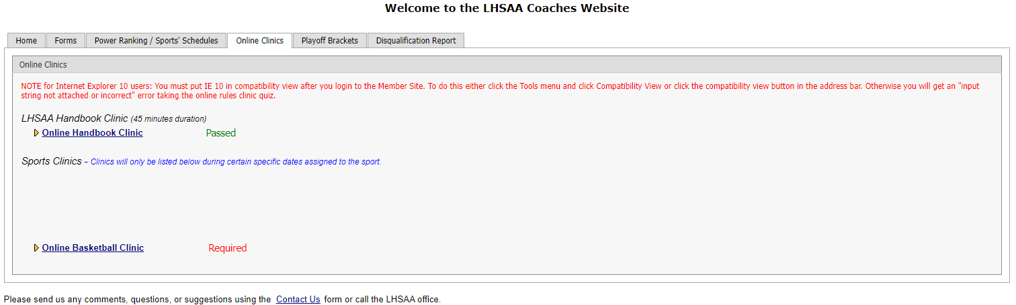

2023-24 Basketball General Information Bulletin | 5

instructions for entering BASKETball schedules into the lhsaa member site

Jamborees, junior varsity and/or Hall of Fame games are not entered into your online schedules as they do not receive power points.

- Log on to www.lhsaaonline.org using your assigned username and password

- Click the Power Ranking Tab

- Click Basketball Power Ranking

- To add games to your schedule, click the ADD button at the top right of the screen

- To add Tournaments, click ADD at the bottom right of the screen. (Only add the tournament games after they are played in the games section)
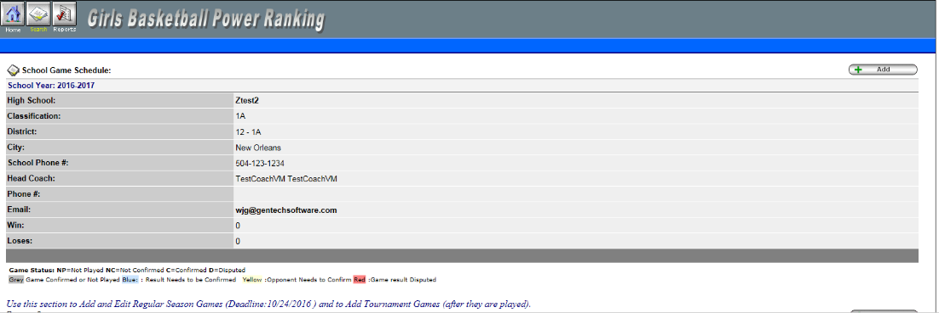

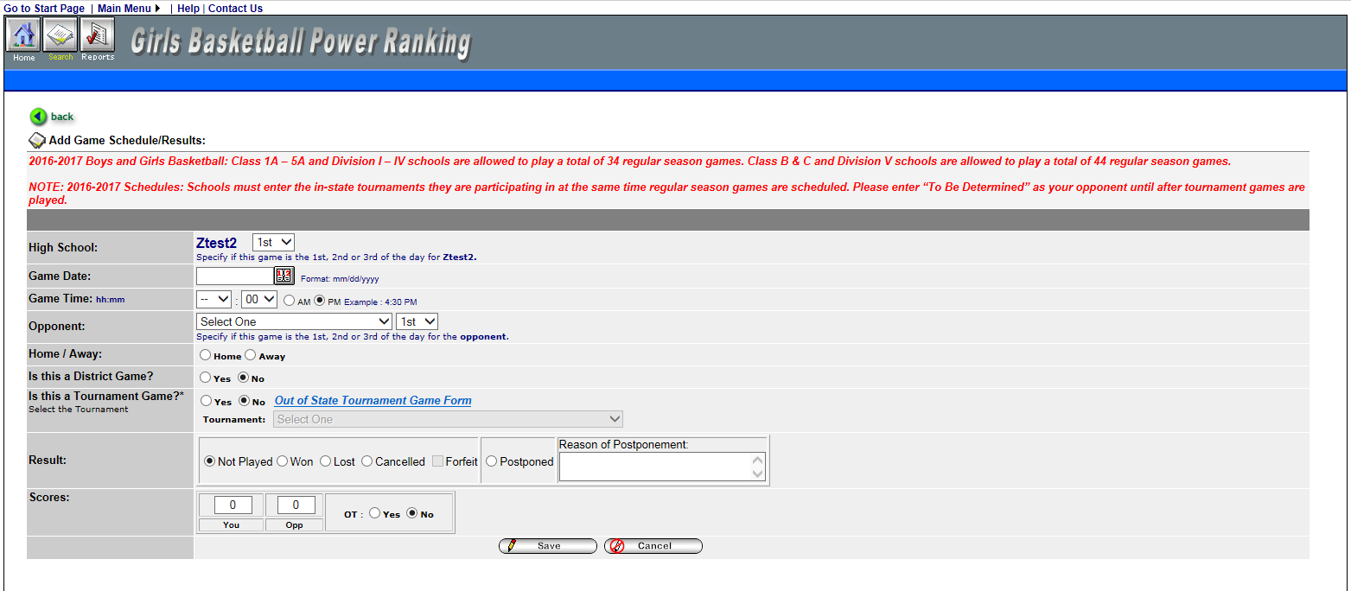

- Enter Game Date, Opponent (from the drop-down list), and be sure to clear the check mark if the game is a district match

- Click SAVE

- On the 1st Official contest date, all games and/or tournaments listed on online schedules shall be considered a binding contract. LHSAA Assistant Executive Director, Karen Hoyt will need email confirmation from both coaches agreeing to any/all changes, updates and/or deletions of match(s) in question.

** The Home Teams’ score books shall serve as the official documentation to resolve all score disputes and is responsible for entering the game results with the opposing coach receiving an email alert to confirm. **

2023-24 Basketball General Information Bulletin | 6

instructions for entering played GAMES

- Log on to www.lhsaaonline.org using your assigned username and password

- Click EDIT button to enter the game scores and results
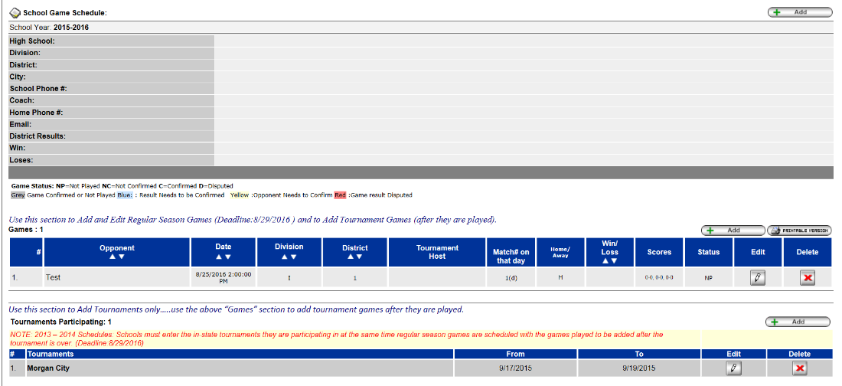

- After the scores have been entered and saved, the system will automatically generate an email and send to the opponents’ head coach for them to confirm the scores and results. These games will be highlighted in YELLOW, which means that the opponent’s head coach needs to confirm the scores and results

confirming a GAME

- Log onto www.lhsaaonline.org using your username and password

- Click EDIT. Games that need to be confirmed by this coach will show highlighted in BLUE

- If the score is correct then click CONFIRM AND SAVE.

- If there is a discrepancy, then click the dispute tab and enter the reason for the dispute and SAVE. The system will automatically send an email to the LHSAA Assistant Executive Director, Karen Hoyt. All disputed games will be highlighted in RED

AT THE END OF THE REGULAR SEASON, THE DISTRICT CHAIR
AND/OR THE HEAD COACH THAT ARE 1ST PLACE IN THEIR DISTRICTS
WILL NEED TO EMAIL ASSISTANT EXECUTIVE DIRECTOR,
KAREN HOYT (khoyt@lhsaa.org) THEIR DISTRICT STANDINGS.

2023-24 Basketball General Information Bulletin | 7

editing playoff brackets

- Log onto www.lhsaaonline.org using your username and password
- You will see 5 tabs – click on the tab that says PLAYOFF BRACKETS

- Click on the EDIT tab that will be located beside the
Basketball Playoff Bracket

- You will see a four-team mini bracket that will show your opponent and the two other teams in your bracket. You will see two boxes – one will say SCORES in it and the other will have TIME/PLACE

- Click on TIME/PLACE to enter the following
- Day of your game
- Time of your game
- Location of game
- Home and Away teams
- Once you have entered the requested information reviewed it for any possible errors, click SAVE & CONFIRM

2023-24 Basketball General Information Bulletin | 8

entering playoff GAME results

- The coach of the winning team will log on to the LHSAA Member site www.lhsaaonline.org (see screen shot on previous page)

- You will see 5 tabs – click on the tab that says PLAYOFF BRACKETS

- Click on the EDIT tab that will be located beside the Basketball Playoff Brackets (see screen shot on previous page)

- You will see a four-team mini bracket that will show your opponent and the two other teams in your bracket. You will see two boxes – one will say SCORES in it and the other will have TIME/PLACE
Steps to follow to enter your game results:
- Click on SCORE to enter your game results
- Click on winning team and enter the score
- Click on losing team and enter the score
- Once you have reviewed the information for any possible
errors

- Click SAVE

*NOTE: The winning team will automatically advance to the regional round on the bracket. The TIME/PLACE screen will open so you can enter the Date, Time, Home Team, Location and location details of the next round. If you do not know your next opponent, please click the CANCEL button. You can enter this information once you know who your next opponent will be. *

Please keep this document and if you have any questions, please contact LHSAA Assistant Executive Director, Karen Hoyt (khoyt@lhsaa.org) or her
Administrative Assistant, S. Lacy Macdiarmid (lmacdiarmid@lhsaa.org).

2023-24 Basketball General Information Bulletin | 9

