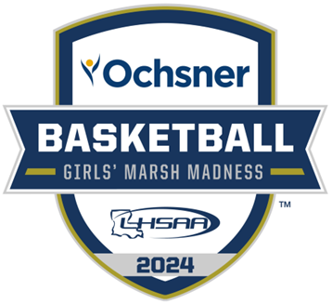

2024 LHSAA STATE

CHAMPIONSHIP BULLETIN

***PLEASE CHECK BACK OFTEN FOR UPDATES!!***

***NO OUTSIDE FOOD OR DRINK - NO EXCEPTIONS!!***

***IT IS YOUR RESPONSIBILITY TO KNOW ANY/ALL LHSAA &***

***UNIVERSITY CENTER POLICIES BEFORE YOUR ARRIVAL.***

table of contents

|  |  |
| --- | --- |
| **CONTENT** | ***PAGE(S)*** |
| basketball important dates | page 1 |
| general information | page 2 |
| site information | page 3 |
| all-academic, non-participating team, support groups, band information | pages 4 |
| media information & yearbook information | page 5 |
| marsh madness hotel information | pages 6 -7 |
| 2023 - 2024 girls’ marsh madness site map | page 8 |
| championship souvenirs | page 9 |
| lhsaa sponsors | page 10 |

2023-24 basketball important dates

*This Bulletin is for your benefit. Please read and make sure all necessary parties receive the correct information concerning the event.*

|  |  |
| --- | --- |
| **DATE** | **EVENT** |
| ***Girls*** – All Classes and Divisions:  Saturday, January 27, 2024 | Deadline to Add Games to Schedule for Power Rating Purposes (All Classes and Divisions) |
| ***Girls*** – All Classes and Divisions:  Saturday, February 10, 2024 | End of Regular Season/District Representatives Named |
| ***Girls*** – All Divisions:  Monday, February 12, 2024 | Playoff Pairings Named/Brackets Released |
| ***Girls*** – All Divisions:  3:00 P.M. - Friday, February 16, 2024  (*LHSAA Bylaws 6.13.6 & 11.10.4)* | Deadline to submit team rosters online.  [***State Tournament Program Roster Submission Instructions***](https://files.constantcontact.com/dddb7521801/5753e63d-c8de-419b-98a8-029d6199ede0.pdf)  ***- Rosters submitted in any/all formats other than the provided format shall be disregarded and will not be included in the program. ZERO EXCEPTIONS!!*** |

|  |
| --- |
| ***Girls’ Playoff Dates*** - ***All Divisions:***  Bi- District Round Deadline – Thursday, February 15, 2024  Regional Round Deadline – Monday, February 19, 2024  Quarterfinal Round Deadline – Thursday, February 22, 2024 |
| ***LHSAA Girls’ Marsh Madness***  Monday, February 26, 2024 – Saturday, March 2, 2024  University Center, Hammond, LA |

2023-24 marsh madness championship

*general information*

*This Bulletin is for your benefit. Please read and make sure all necessary parties receive the correct information concerning the event.*

|  |  |
| --- | --- |
| **CATEGORY** | **DATE/INFORMATION** |
| State Championship Dates and Site | ***Girls’ Marsh Madness Championships:***  February 26, 2024 - March 2, 2024  University Center, Hammond, LA |
| Tournament Director | Karen Hoyt  Assistant Executive Director, LHSAA  Email: [khoyt@lhsaa.org](mailto:khoyt@lhsaa.org)  Phone: (225) 300-4215 |
| Assistant to Tournament Director | S. Lacy Macdiarmid  Administrative Assistant, LHSAA  Email: [lmacdiarmid@lhsaa.org](mailto:lmacdiarmid@lhsaa.org)  Phone: (225) 300-4208 |
| Admission Per Session  ***Clear Bag Policy and all bags will be searched.*** | Tickets - $18.00 + facility fee & taxes  ***NOTE:*** ***A SESSION IS EQUIVALENT TO 1 DAY OF TOURNAMENT PLAY. THERE IS NO RE-ENTRY TO THE FACILITY ONCE YOU EXIT.*** |
| ***IMPORTANT***  University Center  Game Day 411 | To purchase tickets, click ***here***.  For SLU Athletic Venue Policies click [***here***.](https://lionsports.net/tickets) |
| LHSCA Coaches Gate  ***Clear Bag Policy and all bags will be searched.*** | Gate 3 Left of the University Center.  *ALL LHSCA/LHSAA CARDS ARE NON-TRANSFERABLE*  *CARDHOLDERS MUST BE PRESENT WITH A VALID PICTURE ID. THERE IS NO RE-ENTRY TO THE FACILITY ONCE YOU EXIT.* |
| Trainers/  Medical Personnel | Trainers will be provided for all games. Schools must bring their own tape and individual water bottles that do not conflict with LHSAA Partner Powerade. |
| Other | Teams will be allowed to bring individual water bottles that do not conflict with LHSAA Partner Powerade. Water will be provided.  Official Game Ball – Perfection Elite Basketball (BX6E)  2023-24 National Federation Basketball Rules and LHSAA Constitution, Amendments and Bylaws will be followed. |

2023-24 marsh madness championship

*site information*

|  |  |
| --- | --- |
| **CATEGORY** | **DATE/INFORMATION** |
| Team Dropoff & Entry  ***The roster bylaw will be strictly enforced.*** | Buses must drop off teams at Gate 5 Lower. Team buses will park in the Cook Lot.  Each team will be allowed 24 personnel to enter. The 24 includes coaches, players in legal uniform, managers, trainers, and statisticians. Additional team personnel must purchase a ticket and enter through Main Gate. ***ZERO EXCEPTIONS!!*** *(LHSAA Bylaw 6.13.6 & 11.10.4)*  ***SEMI-FINALS ONLY*** - Team and individual pictures will be taken upon arrival your team’s arrival. GeauxPreps requests that all teams arrive in game uniform 1 hour and 30 minutes prior to game.  ***FINALS*** - Teams may enter the facility 1 hour prior to game. |
| Team Uniforms and Dressing Rooms | All teams shall arrive in **GAME UNIFORMS** and need to bring both sets of uniforms. Higher seed will be ***HOME*** team. Your Team Host will take you to your assigned locker rooms.  ***HOME*** – white jerseys ***VISITOR***– dark jerseys |
| Team Roster  Information  *(By-law 6.13.6 & 11.10.4)* | Each team will be allowed 24 personnel to enter. The 24 includes coaches, players in legal uniform, managers, trainers and statisticians. **Per LHSAA Bylaw 6.13.6, once a roster is submitted, it shall be considered final. *No Exceptions!!*** |
| Participating Team Seating | Teams that arrive early and are waiting to play will sit in the following sections:    ***HOME*** – Section 110 ***VISITOR*** – SECTION 103 |
| Team Benches  (when facing score table) | ***University Center:*** **HOME** – Right bench **VISITOR** – Left Bench |
| Pre-Game Warm-Up  ***Practice and game balls***  ***will be provided*** | All teams warm-up on the opposite end of your team bench before each game. The 1st game of the session will be allowed 30 minutes prior to their game to warm-up. All other games will be allowed 15 minutes prior to their game. |
| Pre-Game Protocol | ***Semi-Finals:*** will only be done in the following order before the 1st game of that day. - Prayer, National Anthem, Player Introductions  ***Finals:*** done in the following order before each Championship game.  - Prayer, National Anthem, Game Ball Presentation, Player Introduction |
| Post-Game Interviews  ***(Failure to comply shall be penalized under By-law 5.11.14)*** | Room 104; Coaches shall be responsible for the following:   1. Attending the post-game interview session immediately following their game. 2. Ensuring any/all players, requested by media, attends the post-game interview session immediately following their game. |

2023-24 all-academic, NON-PARTICIPATING TEAMs,

& Support group information

|  |  |
| --- | --- |
| **CATEGORY** | **DATE/INFORMATION** |
| All-Academic Recipients  ***Clear Bag Policy and all bags will be searched.*** | All-Academic recipient entrance is located at Gate 5 Lower at the University Center and will sit in Section 105.  All-Academic recipients and their Administrators have been contacted by the LHSAA office. If you have any questions, please contact Renee’ Ballard at [rballard@lhsaa.org](mailto:rballard@lhsaa.org) |
| Non-Participating Teams  ***Clear Bag Policy and all bags will be searched.*** | Any team that has played a semi-final game and is no longer participating in the tournament shall be accompanied by their head coach and enter together at Gate 5 Lower at the University Center to enter free of charge. |
| Spirit Groups &  Half-Time Performance Information  ***Clear Bag Policy and all bags will be searched.*** | All Spirit (cheer/dance/pep/etc.) sponsors and/or uniformed participants, ***SHALL*** enter together when checking in at Gate 5 Upper at the University Center to enter free of charge. LHSAA will count and invoice member school $18.00 each for any/all additional Spirit (cheer/dance/pep/etc.) sponsors and/or participants over 25.  *Any/all music for all half-time performances shall provide music on iPad, iPhone, etc. as well as any/all necessary adapters.* ***NO MATS OR STUNTING ALLOWED!*** |
| Bands  ***Clear Bag Policy and all bags will be searched.*** | Any and all Band Directors and/or members ***SHALL*** enter together when checking in Gate 5 Upper at the University Center, will be counted and your school invoiced $18.00 each for every Director, Sponsor and/or Member. Band directors, sponsors and/or members without instruments and/or not or in uniform shall purchase full tickets and enter through spectator entrance.  ***Home Section:*** 212A/B ***Visitor Section:*** 201A/B |
| Participating School Supervision & Responsibilities | Schools shall be responsible for including but not limited to the following:   1. LHSAA Bylaws 3.1; 3.1.1; 3.1.2; 3.1.3 & 3.1.4 2. Informing all their athletes, students, fans, etc. of any/all LHSAA and/or University Center prohibited items, policies, etc. 3. Any and all actions and/or behavior of all their athletes, students and/or fans etc.   Failure to do so shall result in the offending school being fine. *(LHSAA Bylaw 5.11.11)* |
| Signs and Decorations | Decorations and signs are permissible; however, they must:  - Be in good taste and illustrate good sportsmanship.  - Be on paper or cardboard and may have shiny surface.  - Be hung using blue tape on any and all surfaces. ***No*** duct tape or scotch tape.  - Schools shall be responsible for informing their boosters, fans and/or support groups. |
| Prohibited Items  & Policies  ***Clear Bag Policy and all bags will be searched.*** | [***Southeastern Athletics Game Day Information & Clear Bag Policy***](https://lionsports.net/tickets)  LHSAA prohibited items can be found in the ***[Official LHSAA](https://online.flippingbook.com/view/73641460/92/)***  ***[Online Handbook.](https://online.flippingbook.com/view/73641460/92/)***    ***All unauthorized items will be taken and can be picked upon the completion for contest.*** |

2023-24 MEDIA/SCHOOL YEARBOOK

*(Please read the LHSAA Media Policy found on the LHSAA Website)*

|  |  |
| --- | --- |
| **CATEGORY** | **DATE/INFORMATION** |
| Media &  School Yearbook | - School media credential candidates must complete the same electronic credential application as the professional media. This application can be found on the LHSAA Website under “News & Media” on the left column. Please then click “2023-2024 LHSAA Media Credential Application Portal.”  - The individuals submitted by an LHSAA member school must submit proper school identification to receive credentials to enter the state championship. Each member school shall be limited to a maximum of two media credentials per event.  - One student and one adult faculty chaperon OR two students.  - Faculty school photographers with school identification may apply for state championship credentials.  *Yearbook sponsors that are not faculty members will not receive LHSAA media credentials. *  - If a school media department would like to request state championship/semi-final photographs for yearbook/media purposes, please email Michael Odendahl of GeauxPreps ([bigshock77@yahoo.com](mailto:bigshock77@yahoo.com)) for five complimentary state championship/semi-final photos. Photographs shall be limited to only the school's team members while in competition.  *School media members will not be permitted on the field/court during post-game celebrations. * |
| Radio/Internet Broadcasting  & Game Video | * Fee per game/match - $150 * Stations broadcasting will be responsible for charge to originating point.   - NFHS Network will be broadcasting and live streaming entire tournament*.* ([www.nfhsnetwork.com](http://www.nfhsnetwork.com)).  - Live streaming of any kind is strictly prohibited during the entirety of the championships. Fines shall be levied against any person/persons attending school caught live streaming without written consent from the LHSAA. |

2023-24 hotel information

|  |  |
| --- | --- |
| **CATEGORY** | **INFORMATION** |
| Hotel Supervision | - Teams must be supervised at all times! The school will be responsible for any damage to assigned rooms or hotels and their property. |
| Hotel Booking Procedures | - Information posted will be posted below as the LHSAA receives it.  - Schools are responsible for securing their own hotel accommodations.  - All reservations are to be made by the individual teams at the hotel of your choice.  - All reservations will be accepted on a first come, first serve basis.  - All rooms must be guaranteed. Please supply credit card information at the hotel of your choice.  - When calling the hotel, please tell them that you are with the LHSAA to receive the discounted rate.  - All cancellations should be made directly with the hotel. |

2023-24 hotel information continued

2023-24 site map

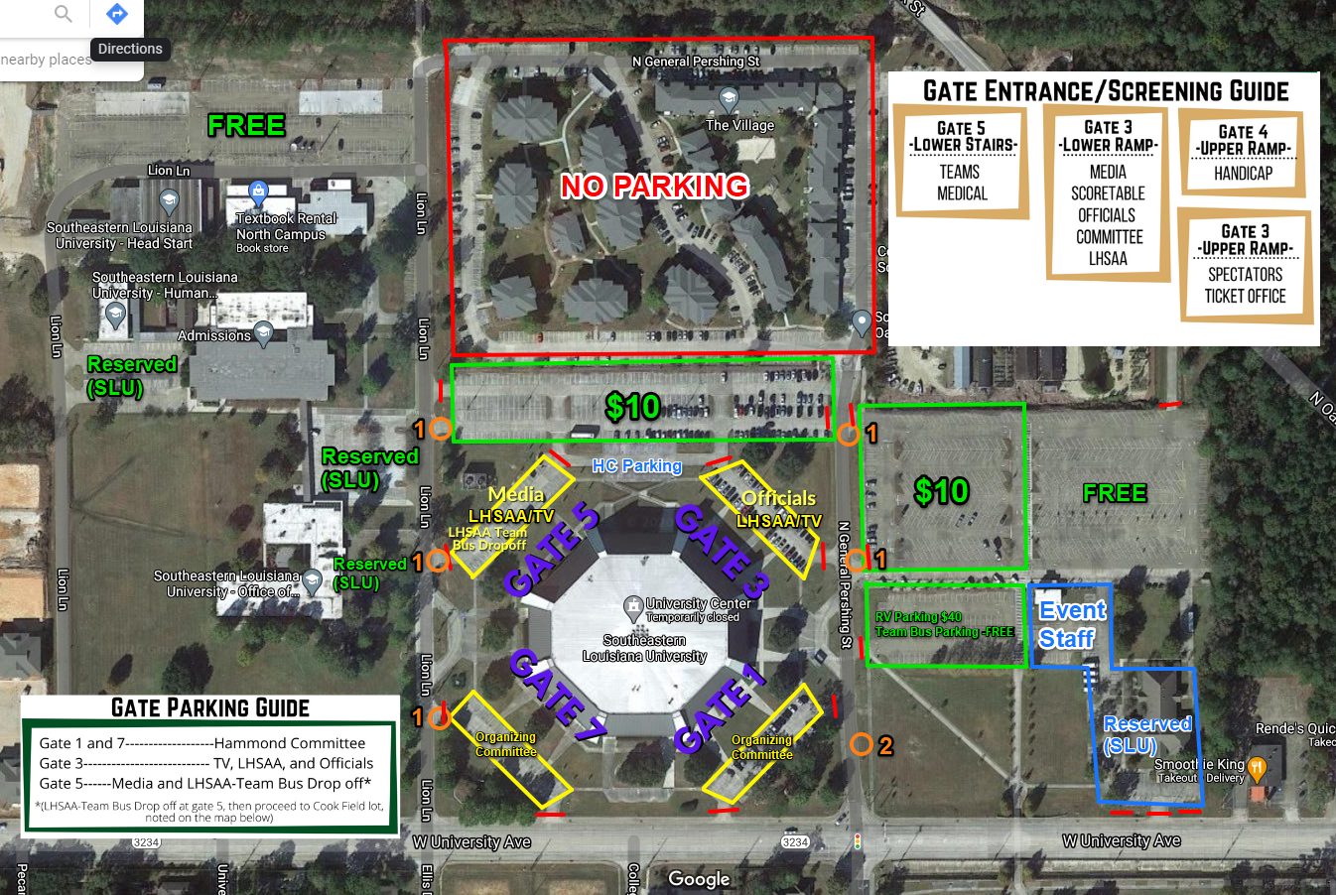 **University Center Map – Hammond, LA**

2023-24 CHAMPIONSHIP SOUVENirs

|  |  |
| --- | --- |
| **CHAMPIONSHIP APPAREL** | Remember this achievement. Visit the PepWear Store or shop.lhsaa.org to purchase Official Event Merchandise  including shirts and hoodies with participants’ names on  the back, full color plaques, and more!  For assistance with orders contact (866) 775-3450 or  [customerservice@pepwear.com](mailto:customerservice@pepwear.com) |
| **Championship photographs** | GeauxPreps is proud to be the official photographer of the Louisiana High School Athletic Association. Please stop by our booth during all of the  LHSAA Championships to view and order photos. Team and individual, action, and all awards photos will be available for purchase and will be printed on site.  <https://geauxpreps.com/photos/> |
| **Championship rings** | Congratulations champions! Celebrate your victory with your championship ring- the ultimate symbol of dedication, perseverance and teamwork. Herff Jones is proud to be the exclusive provider for LHSAA and LHSCA Championship Jewelry and is the recognized leader in celebrating student milestones.  Harris Beall, Clint Ivey, Donald Scamardo  Baton Rouge, LA // 225.927.1383 //[gshhbrla@gradsupply.biz](mailto:gshhbrla@gradsupply.biz)  Metairie, LA // 504.737.4439 // [gradsupply@aol.com](mailto:gradsupply@aol.com) |
| **Championship replica trophies** | For more information regarding State Championship  mini replica trophies and medals, contact  Gold Star Trophies at (225) 928-4230.  [www.goldstartrophies.com](http://www.goldstartrophies.com) |

2023-24 LHSAA SPONSORS

