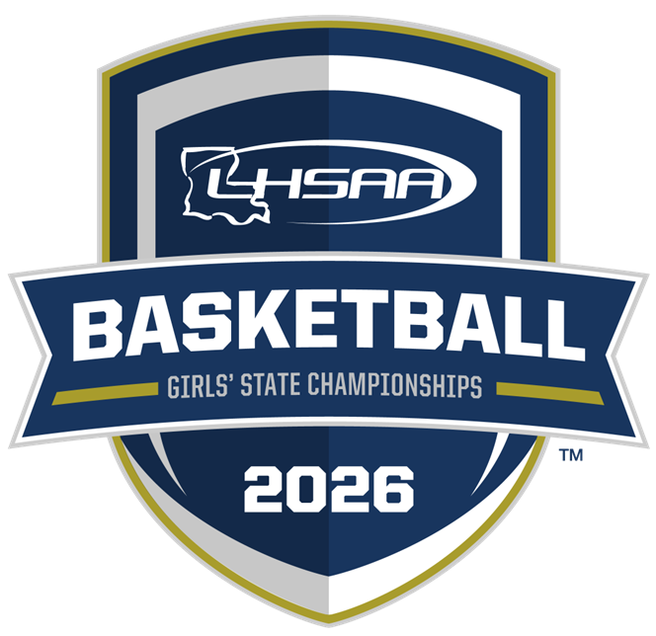

2026 LHSAA STATE
CHAMPIONSHIP BULLETIN
PLEASE CHECK BACK OFTEN FOR UPDATES!!
NO OUTSIDE FOOD OR DRINK - NO EXCEPTIONS!!

table of contents

CONTENT | PAGE(S)
basketball important dates | page 1
general information | page 2
site information | page 3
all-academic, non-participating team, support groups, band information | pages 4
media information & yearbook information | page 5
marsh madness hotel information | pages 5 -7
2025 - 2026 girls’ marsh madness site map | page 8
championship souvenirs | page 9
lhsaa sponsors | page 10
Clean Bag Policy | page 11

2025-26 basketball important dates

This Bulletin is for your benefit. Please read and make sure all necessary parties receive the correct information concerning the event.

DATE | EVENT
Girls – All Classes and Divisions:  Saturday, January 31, 2026 | Deadline to Add Games to Schedule for Power Rating Purposes
Girls – All Classes and Divisions:  Saturday, February 14, 2026 | End of Regular Season/District Representatives Named
Girls – All Divisions:  Monday, February 16, 2026 | Playoff Pairings Named/Brackets Released
Girls – All Divisions:  3:00 P.M. - Friday, February 20, 2026  (LHSAA Bylaws 6.13.6 & 11.10.4) | Deadline to submit team rosters online.  - Rosters submitted in any/all formats other than the provided format shall be disregarded and will not be included in the program. ZERO EXCEPTIONS!!

Girls’ Playoff Dates - All Divisions:

Bi- District Round Deadline – Thursday, February 19, 2026
Regional Round Deadline – Monday, February 23, 2026
Quarterfinal Round Deadline – Thursday, February 26, 2026

LHSAA Girls’ Marsh Madness

Monday, March 2, 2026 – Saturday, March 7, 2026
University Center, Hammond, LA

1

2025-26 marsh madness championship
general information

This Bulletin is for your benefit. Please read and make sure all necessary parties receive the correct information concerning the event.
CATEGORY | DATE/INFORMATION
State Championship Dates and Site | Girls’ Marsh Madness Championships:  March 2-7, 2026  University Center, Hammond, LA
Tournament Director | Karen Hoyt  Assistant Executive Director, LHSAA  Email: khoyt@lhsaa.org  Phone: (225) 300-4215
LHSCA Director | Jessica Barber, Director, LHSCA  Email: jbarber@lhsaa.org  Phone: (225) 300-4203
Admission Per Session  Clear Bag Policy and all bags will be searched. | Tickets - $18.00 + facility fee & taxes  NOTE: A SESSION IS EQUIVALENT TO 1 DAY OF TOURNAMENT PLAY. THERE IS NO RE-ENTRY TO THE FACILITY ONCE YOU EXIT.
IMPORTANT  University Center  Game Day 411 | To purchase tickets, click below.  Monday – March 2nd  Tuesday – March 3rd  Wednesday – March 4th  Thursday – March 5th  Friday – March 6th  Saturday – March 7th  For SLU Athletic Venue Policies, click here.
LHSCA Coaches Gate  Clear Bag Policy and all bags will be searched. | Gate 5 Upper Right of the University Center.  ALL LHSCA/LHSAA CARDS ARE NON-TRANSFERABLE  CARDHOLDERS MUST BE PRESENT WITH A VALID PICTURE ID. THERE IS NO RE-ENTRY TO THE FACILITY ONCE YOU EXIT.
Trainers/  Medical Personnel | Trainers will be provided for all games. Schools must bring their own tape and individual water bottles that do not conflict with LHSAA Partner Powerade.
Other | Teams will be allowed to bring individual water bottles that do not conflict with LHSAA Partner Powerade. Water will be provided.  Official Game Ball – Perfection ElitePRO BX6E-PRO-00  2025-26 National Federation Basketball Rules and LHSAA Constitution, Amendments and Bylaws will be followed.

2

2025-26 marsh madness championship
site information

CATEGORY | DATE/INFORMATION
Team Dropoff & Entry  The roster bylaw will be strictly enforced.  (LHSAA Bylaws 6.13.6 & 11.10.4) | Buses must drop off teams at Gate 5 Lower. Team buses will park in the Cook Lot.  Each team will be allowed 24 personnel to enter. The 24 include coaches, players in legal uniforms, managers, trainers, and statisticians. Additional team personnel must purchase a ticket and enter through Main Gate. ZERO EXCEPTIONS!!  SEMI-FINALS ONLY - Team and individual pictures will be taken upon your team’s arrival. GeauxPreps requests that all teams arrive in game uniform 1 hour and 30 minutes prior to game.  FINALS - Teams may enter the facility 1 hour prior to game.
Team Uniforms and Dressing Rooms | All teams shall arrive in GAME UNIFORMS and need to bring both sets of uniforms. Higher seed will be HOME team. Your Team Host will take you to your assigned locker rooms.  HOME – white jerseys VISITOR– dark jerseys
Team Roster  Information  (LHSAA Bylaws 6.13.6 & 11.10.4) | Each team will be allowed 24 personnel to enter. The 24 include coaches, players in legal uniform, managers, trainers and statisticians. Per LHSAA Bylaw 6.13.6, once a roster is submitted, it shall be considered final. No Exceptions!!
Participating Team Seating | Teams that arrive early and are waiting to play will sit in the following sections:  HOME – Section 111 VISITOR – SECTION 102
Team Benches  (when facing score table) | University Center: HOME – Right bench VISITOR – Left Bench
Pre-Game Warm-Up  (Practice and game balls  will be provided) | All teams' warm-up on the opposite end of your team bench before each game. The 1st game of the session will be allowed 30 minutes prior to their game to warm-up. All other games will be allowed 15 minutes prior to their game.
Pre-Game Protocol | Semi-Finals: will only be done in the following order before the 1st game of that day. - Prayer, National Anthem, Player Introductions  Finals: done in the following order before each Championship game.  - Prayer, National Anthem, Game Ball Presentation, Player Introduction
Post-Game Interviews  (LHSAA Bylaw 5.11.11) | Coaches shall be responsible for the following:  - Attending the post-game interview session immediately following their championship game.  - Ensuring any/all players, requested by media, attend the post-game interview session immediately following their game.  Failure to comply shall be penalized under LHSAA Bylaw 5.11.11.

3

2025-26 all-academic, NON-PARTICIPATING TEAMs,
& Support group information

CATEGORY | DATE/INFORMATION
All-Academic Recipients | Your student will be recognized by printing the certificate and honoring the student at your sports award banquets. If you have any questions, please contact Renee’ Ballard at rballard@lhsaa.org
Non-Participating Teams  Clear Bag Policy and all bags will be searched. | Any team that has played a semi-final game and is no longer participating in the tournament shall be accompanied by their head coach and enter together at Gate 5 Lower at the University Center to enter free of charge.
Spirit Groups &  Half-Time Performance Information  Clear Bag Policy and all bags will be searched. | All Spirit (cheer/dance/pep/etc.) sponsors and/or uniformed participants, SHALL enter together when checking in at Gate 5 Upper at the University Center to enter free of charge.  Any/all music for all half-time performances shall provide music on iPad, iPhone, etc. as well as any/all necessary adapters. NO MATS OR STUNTING ALLOWED!
Bands  Clear Bag Policy and all bags will be searched. | Any and all Band Directors and/or members SHALL enter together when checking in Gate 5 Upper at the University Center. Band directors, sponsors and/or members without instruments and/or not or in uniform shall purchase full tickets and enter through spectator entrance.  Home Section: 210A/B Visitor Section: 220A/B
Participating School Supervision & Responsibilities  (LHSAA Bylaw 5.11.11) | Schools shall be responsible for including but not limited to the following:  - LHSAA Bylaws 3.1.1(1-4) & 3.1.3  - Informing all their athletes, students, fans, etc. of any LHSAA and/or University Center prohibited items, policies, etc.  - Any and all actions and/or behavior of all their athletes, students and/or fans etc.  Failure to comply shall be penalized under LHSAA Bylaw 5.11.11.
Signs and Decorations | Decorations and signs are permissible; however, they must:  - Be in good taste and illustrate good sportsmanship.  - Be on paper or cardboard and may have shiny surface.  - Must be hung using blue tape on all surfaces. No duct tape or scotch tape.  - Schools shall be responsible for informing their boosters, fans and/or support groups.
Prohibited Items  & Policies  Clear Bag Policy and all bags will be searched. | 6.24 PROHIBITED ITEMS  6.24.1 Authorized pep bands shall not be permitted to play at any time and in any manner while the ball is “alive.”  6.24.2 Laser beam light devices shall be prohibited at all LHSAA contests.  6.24.3 A coach, player, and/or bench personnel shall be prohibited from throwing/placing any foreign substances on the competitive surface and out-of-play areas (including locker rooms, hallways, press  rooms, etc.) prior to, during, and/or after playing any game. Substances to include but not limited to all liquids, powders, confetti, glitter, dirt, sand, grass, and streamers. Schools not adhering to the  Prohibited Items Bylaw could be fined up to $250 per incident.
4

2025-26 MEDIA/SCHOOL YEARBOOK

(Please read the LHSAA Media Policy found on the LHSAA Website)
CATEGORY | DATE/INFORMATION
Media/Radio/  Internet Broadcasting  & Game Video | - For any/all media information and questions, please contact Ethan Anderson @ eanderson@lhsaa.org.  - LHSAA Media  - LHSAA Media Guidelines  - 2025-2026 Media Credential Application
Radio/Internet Broadcasting  & Game Video | - Fee per game/match - $150  - Stations broadcasting will be responsible for charging to originating point.  - All Rounds will broadcast live by and through the NFHS Network. (www.nfhsnetwork.com).  - Live streaming is strictly prohibited during the entire tournament as they are available on the NFHS Network.

2025-26 hotel information

CATEGORY | INFORMATION
Hotel Supervision | - Teams must be always supervised! The school will be responsible for any damage to assigned rooms or hotels and their property.
Hotel Booking Procedures | - Information posted will be posted below as the LHSAA receives it.  - Schools are responsible for securing their own hotel accommodations.  - All reservations are to be made by the individual teams at the hotel of your choice.  - All reservations will be accepted on a first-come, first-serve basis.  - All rooms must be guaranteed. Please supply credit card information at the hotel of your choice.  - When calling the hotel, please tell them that you are with the LHSAA to receive the discounted rate.  - All cancellations should be made directly with the hotel.

5

2025-26 hotel information continued

6

7

2025-26 site map

University Center Map – Hammond, LA

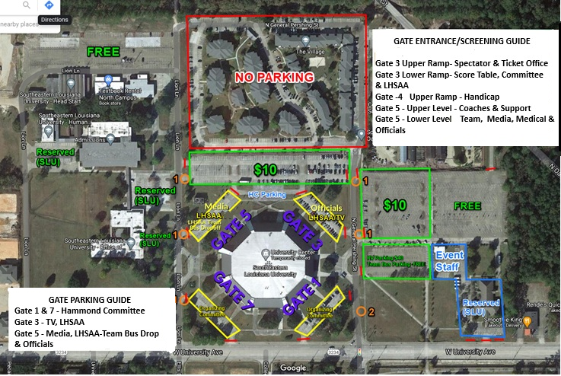

8

2025-26 CHAMPIONSHIP SOUVENirs

CHAMPIONSHIP APPAREL   | ✨ Apparel as Unique as YOU! ✨  Don’t miss out on your Official Event Merchandise!  Stop by the Fine Designs booth at any championship event to create your own customized apparel onsite — or shop anytime online at LHSAAStore.com.  📞 Questions? Call us at 214-620-1326  📧 Email: Support@FineDesigns.com
Championship photographs   | GeauxPreps is proud to be the official photographer of the Louisiana High School Athletic Association. Please stop by our booth during all the LHSAA Championships to view and order photos. Team and individual, action, and all awards photos will be available for purchase and will be printed on site.  https://geauxpreps.com/photos/
Championship rings | Congratulations, champions! Celebrate your victory with your championship ring- the ultimate symbol of dedication, perseverance and teamwork. Herff Jones is proud to be the exclusive provider for LHSAA and LHSCA Championship Jewelry and is the recognized leader in celebrating student milestones.  Harris Beall, Clint Ivey, Donald Scamardo  Baton Rouge, LA // 225.927.1383 //gshhbrla@gradsupply.biz  Metairie, LA // 504.737.4439 // gradsupply@aol.com
  Championship replica trophies | For more information regarding State Championship  mini replica trophies and medals, contact  Gold Star Trophies at (225) 928-4230.  www.goldstartrophies.com

9

2025-26 LHSAA SPONSORS

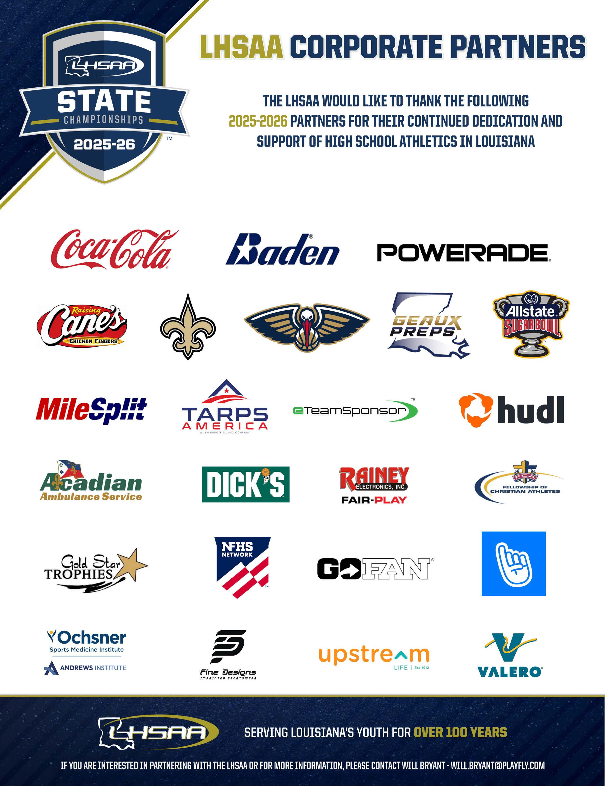

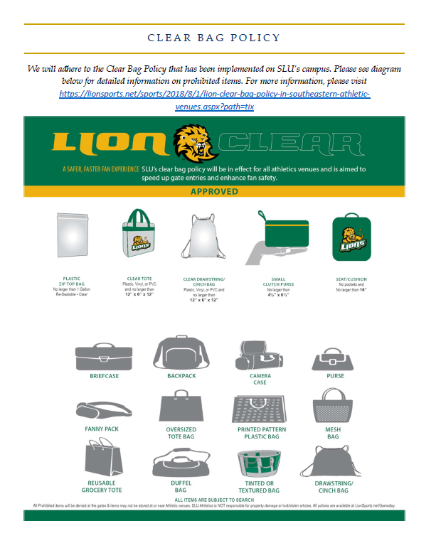

11

