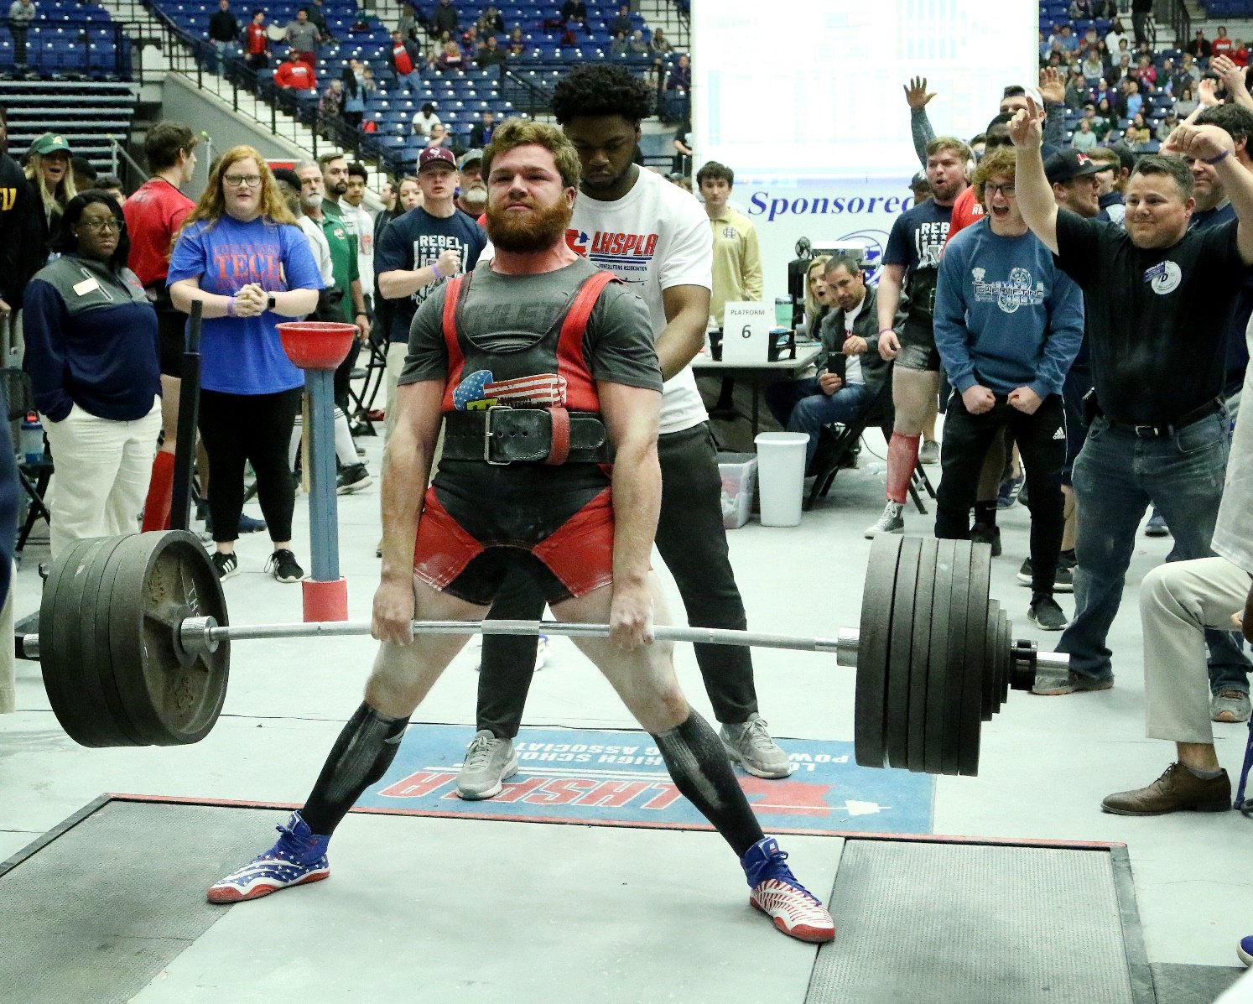
LOUISIANA HIGH SCHOOL ATHLETIC ASSOCIATION

2023-24 LHSAA POWERLIFTING
State Championship Bulletin

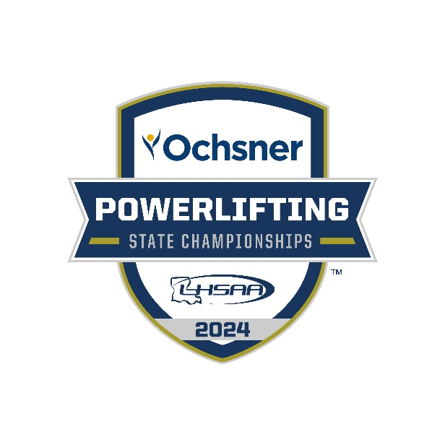

table of contents

CONTENT | PAGE(S)
State Meet Information  - meet director  - site specifics  - admission  - coaches meeting  - meet schedule | Pages 4-6
important reminders & Rules  - awards  - appeals  - officials  - scoring | Pages 7-8
Uniforms  - rules briefing info for squat, bench press & deadlift | Pages 8-16
Media | Page 17
Championship Souvenirs | Page 18
LHSAA corporate Sponsors | Page 19
hotel rates | Page 20-21

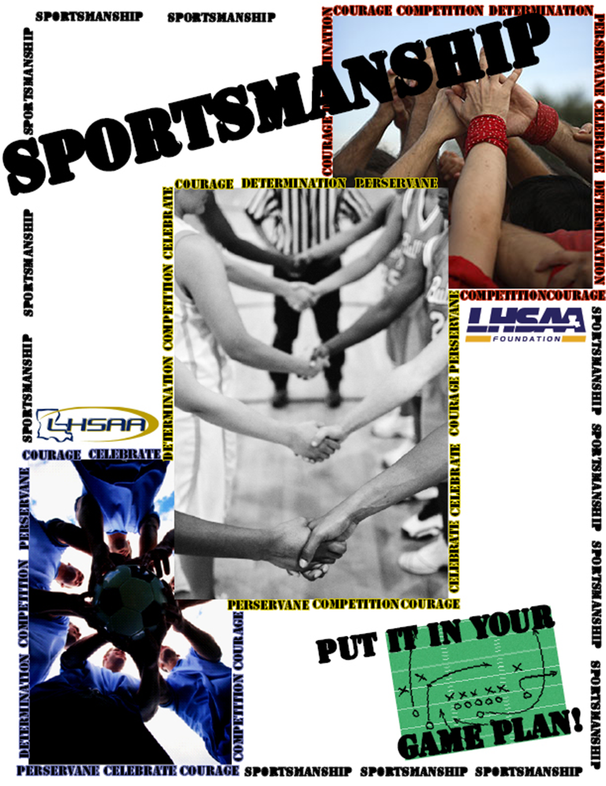

2024 LHSPLA STATE MEET
information

STATE MEET DATES | SITES | MEET DIRECTOR
Wednesday Morning  March 20, 2024  Div. IV-V BOYS  (Classes 2A, 1A) | LAFAYETTE CAJUNDOME | Duane Urbina  dpurbina@gmail.com
Thursday Morning  March 21, 2024  Div. IV-V GIRLS  (Classes 2A, 1A) | LAFAYETTE CAJUNDOME | Duane Urbina  dpurbina@gmail.com
Friday Morning  March 22, 2024  Div. I-II-III GIRLS  (Classes 5A, 4A, 3A) | LAFAYETTE CAJUNDOME | Duane Urbina  dpurbina@gmail.com
Saturday Morning  March 23, 2024  Div. I - III BOYS  (Classes 5A, 4A, 3A) | LAFAYETTE CAJUNDOME | Duane Urbina  dpurbina@gmail.com
Admission: $20

2024 lhsaa/lhspla division I-v
state meet schedule

BOYS DIVISIONS IV & V
BOYS EARLY WEIGH-IN | TUESDAY, MARCH 19th - 6:00 – 8:00 P.M.  LAFAYETTE CAJUNDOME
BOYS’ REGULAR WEIGH-IN | WEDNESDAY, MARCH 20th – 7:30 – 9:00 A.M.
BOYS’ STATE BUSINESS MEETING | WEDNESDAY, MARCH 20th – 8:00 A.M.  HOSPITALITY ROOM
BOYS’ LIFTING STARTS | WEDNESDAY, MARCH 20th– 10:00 A.M.  LAFAYETTE CAJUNDOME

GIRLS DIVISIONS IV & V
GIRLS’ EARLY WEIGH-IN | WEDNESDAY, MARCH 20th – 6:00 – 8:00 P.M.  LAFAYETTE CAJUNDOME
GIRLS’ REGULAR WEIGH-IN | THURSDAY, MARCH 21st – 7:30 – 9:00 A.M.
GIRLS’ STATE BUSINESS MEETING | THURSDAY, MARCH 21st – 8:00 A.M.  HOSPITALITY ROOM
GIRLS’ LIFTING STARTS | THURSDAY, MARCH 21st – 10:00 A.M.  LAFAYETTE CAJUNDOME

2024 lhsaa/lhspla division I-v
state meet schedule
-cONTINUED-

GIRLS DIVISIONS I, II & III
BOYS’ EARLY WEIGH-IN | THURSDAY, MARCH 21st – 6:00 – 8:00 P.M.  LAFAYETTE CAJUNDOME
BOYS’ REGULAR WEIGH-IN | FRIDAY, MARCH 22nd – 7:30 – 9:00 A.M.
BOYS’ STATE BUSINESS MEETING | FRIDAY, MARCH 22nd – 8:00 A.M.  HOSPITALITY ROOM
BOYS’ LIFTING STARTS | FRIDAY, MARCH 22nd – 10:00 A.M.  LAFAYETTE CAJUNDOME

BOYS DIVISIONS I, II & III
BOYS’ EARLY WEIGH-IN | FRIDAY, MARCH 22nd – 6:00 – 8:00 P.M.  CAJUNDOME
BOYS’ REGULAR WEIGH-IN | SATURDAY, MARCH 23rd – 7:30 – 9:00 A.M.
BOYS’ STATE BUSINESS MEETING | SATURDAY, MARCH 23rd – 8:00 A.M.  HOSPITALITY ROOM
BOYS’ LIFTING STARTS | SATURDAY, MARCH 23rd – 10:00 A.M.  CAJUNDOME

IMPORTANT REMINDERS & RULES
AWARDS | - The presentation of Academic All- State Powerlifters will be at the beginning of each respective meet.  - INDIVIDUAL AWARDS: LHSAA/LHSPLA STATE MEET  Medals will be awarded to the top 3 lifters in each weight class at the LHSAA/LHSPLA State Meet. Outstanding lifter trophies for the light and heavy platforms at both the boys’ and girls’ meet will be awarded in all Divisions (I – V). The size and make-up of the medals, individual trophies at the State Meets are to be made up to the prescribed specifications of the LHSAA Executive Committee.  - The girls’ outstanding lifter trophies (Division I – V) at the state meet will be divided into the light and heavy platforms using the following criteria:  Light Platform – 97 lb. – 148 lb. Weight classes  Heavy Platform – 165 lb. – SHW Weight classes  - The boys’ outstanding lifter trophies (Division I – V) at the state meet will be divided into the light and heavy platforms using the following criteria:  Light Platform – 114 lb. – 165 lb. Weight classes  Heavy Platform – 181 lb. – SHW Weight classes  - The Wilks Coefficient will be used to determine the Outstanding Lifter Award.  - State Championship Awards are tentatively set for 5:00 PM each day.
Officials Furnished | - All lifting platforms will be staffed with highest rated certified LHSPLA meet officials. The head referee in charge will determine the order in which judges work at the LHSAA/LHSPLA state meet.
Responsible for Scoring | - Official scorer for the meet will be Mary Ralston, Natchitoches Central High School
Appeals | - If deemed necessary, the Head Referee or Meet Director and the LHSPLA Executive Committee members present may temporarily suspend the progress of the competition and retire to consider a decision on a Formal Complaint. The Head Referee, Meet Director and the LHSPLA Executive Committee may enlist the help of the Chief Referees from each platform to consider the complaint. Once a decision has been made, it shall be considered final and there will be no right of appeal.  - All decisions, rulings, or judgments by platform officials involving or relating to whether a lifter has complied with rules of performance are not appealable. The only appealable matters are those related to misloads, lifting order, clerical errors on overheads/expeditor sheets or lifting cards or complaint against the behavior of a person, persons, or team either taking part in the competition or person or persons associated with a team in the competition or warm-up area.  - Any appealable matter described above or complaint must be immediately lodged in writing to the Chief Referee on the platform following the action.  - COACHES MUST REMEMBER TO CHECK ALL RESULTS AS THEY ARE POSTED.
Uniforms | APPROVED SUPPORTIVE EQUIPMENT  The list of approved supportive equipment listed below will be used as a guide in determining whether the supportive equipment utilized by a lifter is legal or not This guide shall also be posted on the LHSPLA website.  Any successful State record lift will be followed by a cursory examination of the supportive equipment utilized in that lift to determine whether the supportive equipment utilized by the lifter is legal. If the supportive equipment is found to be illegal; the lifter will not get credit for  the successful record lift, but in no case shall any previous lift be taken away unless the infraction was noticed, the coach was informed of the  infraction and the infraction went uncorrected.

LIST OF APPROVED SUPPORTIVE EQUIPMENT

Inzer | Titan | Metal | Ken Anderson
Z-Suit | Squat Suits | Metal Squatter | KLA 2000 Gold Knee Wraps 2.0M
Champion Suit | Centurion Suits | Metal Viking Squatter | KLA 2000 Knee Wraps 2.0m
Hard Core Suit | Red Devil wraps | Metal Squatter v-type | THP Knee Wraps 2.0m
TRX Squat Suit | Signature Gold wraps | Metal Viking Squatter v-type | Max RPM Knee Wraps 2.0m
Megathrust Squat Suit | Titanium wraps | Metal King Squatter | Titanium Knee Wraps 2.0m
MAX DL Deadlift suit | Velocity Deadlift Suit | Metal King Squatter V-type | Signature Gold Knee Wraps 2.0m
Fusion Deadlift suit | Titan Fury Shirts | Metal Bencher | KLA 2000 Gold Wrist Wraps 18"
XDL Deadlift suit | Knee Wraps T.H.P. (with lettering or yellow stripe) | Metal Viking Bencher | THP Wrist Wraps 12"
Iron Wraps A and Z | Knee Wraps Max RPM (Black with green, pink or orange stripes) | Metal Viking Bencher X Type | THP Wrist Wraps 18"
Erector Shirt | Wrist Wraps T.H.P. (with lettering or yellow stripe) | Metal Viking Presser | KLA 2000 - 24" Lime Wrist Wraps
Sleeveless Erector Shirt | Wrist Wraps Max RPM (Black with green, pink or orange stripes) | Metal Presser | Max RPM Wrist Wraps 24"
Heavy Duty Erector Shirt | F6 Tornado Shirt | Metal Deadlifter | Max RPM Wrist Wraps 36"
Sleeveless Heavy Duty Erector Shirt | Fury NXG Plus SHP Bench Shirt | Metal Viking Deadlifter | Signature Gold Wrist Wraps 12 inch
Blast Shirt | Katana Shirts | Metal King Sumo Deadlifter | KLA 3000 Lime Wrist Wraps 36"
Heavy Duty Blast Shirt (HD) | Super Katana | Metal King Deadlifter | KLA 2000 Gold Wrist Wraps 24"
High Performance Heavy Duty Blast Shirt (HPHD) | Super Katana low cut | Metal Blackline Wraps | KLA 2000 wrist wraps 18"
Extra High Performance Heavy Duty Blast Shirt (EHPHD) | Super Centurion | Metal Black Wraps | KLA 1000 Wrist Wraps 24"
Inzer | Titan | Metal | Ken Anderson
Phenom shirt | Spartan Suits | Metal Triple Blackline Wraps | Titanium Wrist Wraps 24"
The Wrath bench shirt | Titan Knee Sleeves | Mystical Wraps | KLA 3000 Wrist Wraps 24"
The Rage bench shirt | Titan Knee Sleeves – Yellow Jacket | Silver and Orange Wraps | KLA 4000 Double Super Heavy Plus Wrist Wraps 24"
Rage-X bench shirt | Titan Singlet | King Bencher | Titanium Wrist Wraps 36"
XB bench shirt | ELEIKO | King Presser | KLA 4000 Double Super Heavy Plus Wrist Wraps 36"
BOLT bench shirt | ELEIKO Knee Sleeves | King bencher x-type | KLA 1000 Wrist Wraps 18"
Wrist True Black Wrap | REHBAND | Metal Knee Sleeves | Max RPM Wrist Wraps 12"
Knees True Black Wrap | Rehband Knee Sleeves | Metal Singlets | Max RPM Wrist Wraps 18"
W30 Wraps | SBD | Strengthshop | THP Wrist Wraps 24"
W40 Wraps | SBD Knee Sleeves | Strengthshop Knee Sleeves | KLA 3000 Lime Wrist Wraps 24"
W50 Wraps | SBD Singlets | Strengthshop Singlets | KLA 2000 Wrist Wraps 36"
W60 Wraps | SBD Wrist Wraps |  | Signature Gold Wrist Wraps 18 inch
W70 Wraps | Bukiya.net |  | Signature Gold Wrist Wraps 24 inch
W80 Wraps | Oni Sleeves (Knee Sleeves) |  | Titanium Wrist Wraps 12"
INZER Singlets |  |  | Titanium Wrist Wraps 18"
 |  |  | KLA 2000 Wrist Wraps 24"
 |  |  | KLA 2000 Gold Wrist Wraps 36"
 |  |  | THP Wrist Wraps 36"
 |  |  | KLA 2000 - 36" Lime Wrist Wraps
 |  |  | KLA 3000 Wrist Wraps 36"
 |  |  | Signature Gold Wrist Wraps 30 inch

UNIFORM (LIFTING SUIT) | - General Rule  A lifting suit shall be worn consisting of a one-piece full-length lifting suit of one-ply stretch material without any additional patches or padding. The straps shall be worn over the shoulders at all times while the lifter is on the platform. The lifting suit may not be made of any materials such as spandex. A t-shirt with a hemmed sleeve that does not extend below the elbow must be worn under the lifting suit or singlet when on the platform and during the execution of a lift.  If a lifter chooses to compete in a lifting singlet it is recommended that it meets the requirements listed in rule 2-B, 1 – 7. No singlet shall be worn that gives a lifter an unfair or competitive advantage over other lifters.  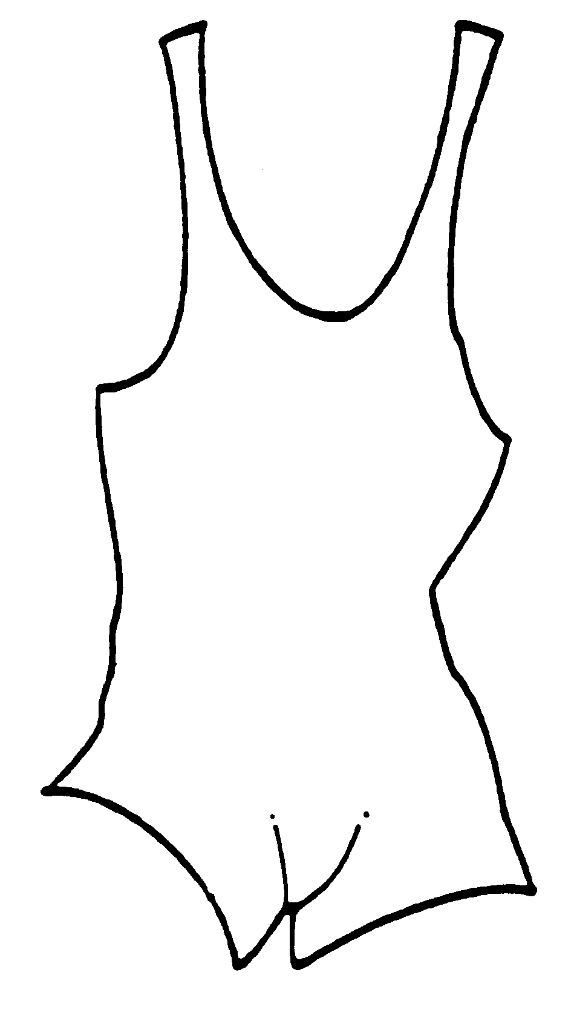  Length of leg from top seam of crotch = 6"  - Specific Rules  (1) The crotch panel shall be of one-ply for suits used in the squat and the deadlift.  (2) A folded strap or a strap that has a piece of material added is legal on a suit as long as it does not increase the total thickness of the suit. Any suit that has been torn and has been subsequently repaired with an acceptable one- ply material should be legal as long as it does not increase the total thickness of the suit.  (3) There shall be no obscene or profane markings on lifting attire worn on the platform or at the meet site.  (4) The length of the leg shall not exceed 6 inches from the middle of the crotch to the edge of the leg length. This measurement should be taken when the suit is lying unworn on a table.  (5) Any alterations to a suit, which exceed the established widths, lengths, or thickness previously mentioned, shall make a suit illegal for competition.  (6) The suit may be any color or colors as long as such design does not prohibit platform officials from being able to judge the lift.  - Lifting suits shall not be inverted (turned inside out), but may be worn in reverse (backwards). This is to insure compliance with the rulebook regarding double ply suits. Alterations that are made by the lifter that causes the suit to become double ply and/or enhances or gives the lifter a competitive advantage over another because of that alteration are strictly prohibited.  - Women’s Specifications  Women shall wear a one-piece suit of comparable design to the lifting suit as long as it meets all of the requirements described in Section III, C. Leotards with sleeves or high cut leg lines are not permitted.  - Emblems, Logos, etc.  Any emblem or logo may be worn on a lifting shirt, equipment, belt, and attire as long as it is not obscene or profane, or deemed as interfering with the platform referee’s job of making decision as to the validity of a lift.
SHIRT | - General Rule  Any type of t-shirt, jersey, or other type of shirt with a hemmed sleeve must be worn; all shirts shall be worn under the lifting suit or singlet. The shirt sleeve must remain above the elbow. The shirt shall be made of one-ply cotton, polyester, or a combination of the two. Bench shirts may be worn if they fit according to the general rule above. No shirts with cut off sleeves will be allowed.  - Specific Rules  It shall not be ribbed or consist of any rubberized materials, denim, or similar stretch materials.  - Emblems, Logos, etc.  See Section III, Rule 2, Article D.
sOCKS | - Socks of any type or color, with any type of logo, emblem, etc. may be worn as long as no obscene or profane markings are present. It is permissible for lifters to wear more than one pair of socks.  - They shall not be so long that they touch any knee wrappings or one-piece knee cap supporter when in use.  - Full length stockings, tights or hose are strictly forbidden.  - Shin length socks must be worn to cover and protect the shins while performing the deadlift. The socks cannot extend higher than the crease in the knee joint at the back of the knee.
ATHLETIC SUPPORTER/BRIEFS | - An athletic supporter or standard cotton or nylon brief of a single-ply shall be worn under the lifting suit or gym shorts. Swimming trunks, spandex biking shorts or any other garment consisting of rubberized or stretch material is not permitted. The garment shall have no legs and cannot act as a girdle.  Legal brief Illegal brief
WOMEN’S WEAR BENEATH THE LIFTING SUIT | Under Garments  Women shall wear protective briefs or panties as long as they are not deemed supportive in any way. Women may also wear a bra as long as it does not retain its shape when placed in an upright or flat position. Only one bra (layer of clothing) can be worn beneath a lifters’ t-shirt or bench shirt. Hose or panty hose are not permitted.
BELT

BELT | - A competitor may wear a belt. If worn, it shall be on the outside of the lifting suit.  - Materials and Construction  (1) The main body of the belt shall be made of leather or vinyl in one or more laminations, which may be glued and/or stitched together.  (2) It shall not have any additional padding, bracing, or supports of any material.  (3) Any type of buckle or fastener is permitted provided the underloop of the two ends of the belt does not exceed 4 inches.  (4) A leather tongue shall be attached close to the buckle by means of studs and/or stitching.  (5) One or two prong buckles may be used.  - Dimensions  (1) Maximum belt width - 4 inches.  (2) Maximum belt thickness – ½ inch.  (3) Maximum inside buckle width - 4 1/4 inches.  (4) Maximum outside buckle width - 5 inches.  - Appropriate Emblems, Logo, Etc.  See Section III, Rule 2, Article D.
FOOT ATTIRE ON THE PLATFORM | - General  Any type of uncleated or unspiked shoe or boots with a sole shall be worn.  - Definition of Soles  Shoes shall include boots, sport shoes, cross trainers or any foot covering that has a patterned molded sole.
WRAPS | - General Rule  Wraps may be worn, however, only wraps or bandages of medical crepe or one-ply commercially woven elastic that is covered with polyester, cotton or a combination of both materials is permitted. Bandages of rubber or rubberized substitutes are strictly forbidden. Virtually any type of fastening device is illegal except adhesive tape.  Only wraps from commercial manufacturers listed in Section III-1 of the LHSPLA  Rulebook shall be permitted for use in all LHSPLA sanctioned meets. Knee  Sleeves are now permitted for use at LHSPLA Sanctioned Meets  WRAPS  - Legal Use of Wraps  (1) Wrists - Wraps shall not exceed 3' 3" in length and 3" in width. A combination of two or more wrist wraps is forbidden.  (a) If wristbands are the wrap around style, the Velcro fastener cannot be so long that it completely encircles the wrist. Also if it has a thumb loop fastener, it cannot be secured around the thumb during the execution of the actual lift.  (b) A wrist wrap shall not extend beyond 4 inches above the center of the wrist joint and 3/4 inch below the center of the wrist joint. The total wrap cannot exceed 5 inches in length.  (2) Knees - Wraps shall not exceed 6' 6" in length. A knee wrap shall not extend over 6 inches above or below the center of the knee joint. The total wrap cannot exceed 12 inches.  - Illegal Use of Wraps  (1) Wraps shall not touch the socks or the lifters suit.  (2) Wraps shall not be used elsewhere on the body other than the knees and the wrist.
EQUIPMENT WAIVER ENFORCEMENT AT MEETS | - Coaches will be required to inspect his/her team’s own equipment (lifting suits, belts, and wraps). They will be required to sign a waiver verifying that all equipment that is being used by his/her team complies with Section III of this rulebook.  - If a lifter steps on the platform and is found to be wearing an illegal article or attire of illegal piece of equipment, whether intentional or not, he/she shall accept the consequences of violating LHSPLA rules on platform attire and equipment. The penalty is a warning for a minor infraction, and disqualification of a lift for a major infraction.  - If a lifter performs a lift in a grossly invalid piece of equipment or attire, the lift shall be disqualified and the lifter shall be warned. For minor infractions of attire and equipment the lifter shall be warned and the lift allowed on their first attempt. Repeated use of equipment and attire with minor infractions will result in any subsequent lifts being disqualified. Repeated use of illegal attire and equipment by the lifter shall be cause for disqualification from competition. A lifter, who is found guilty of a major equipment or attire infraction (intentional or unintentional) and uses the same illegal equipment or attire again, shall be disqualified. In no case shall a lift be allowed when a major infraction occurs.
EXAMPLES OF MAJOR RULE INFRACTIONS:  UNIFORMS AND EQUIPMENT | (1) Wraps more than 1 foot over length.  (2) Wearing two sets of wraps.  - Use of two suits, two bench shirts, girdles, braces, reinforced double ply suits, or highly supportive underwear.  - Use of oil, grease, jelly, lotion or other lubricant on legs.  (5) Additional bracing or covering in or on the belt.  (6) Use of elbow wraps.  (7) Wearing obscene or profane apparel on the platform.  (8) Wearing dirty or torn items on the platforms that are deemed to be an embarrassment to the sport.  (9) Wearing items that have been rejected at that competition.  (10) Wearing attire with illegal alterations.  - Wearing a belt that is so long it is wrapped around the lifter and gives the effect of a double belt.  (12) Any use of adhesive tape not approved by the Head Referee or Meet Director  (13) Use of illegal substances on the lifter and/or the lifter’s attire.  (14) Illegal use of plasters (Band-Aids, bandages, etc.) that aid the lifter.  (15) Wearing a football girdle, biker or compression shorts underneath the lifting suit.
EXAMPLES OF MINOR INFRACTIONS | (1) Wraps touching the socks.  (2) Wraps a few inches too long.  (3) Wearing a Belt that is over 4 inches wide.  (4) Wearing more than one t-shirt.  (5) Improperly attached wraps.  (6) Straps on lifting suit not over the shoulders while lifting.  (7) Knee wraps that extend more than 6 inches above or below the knee joint.  (8) Using wraps with Velcro straps that gives joint support.  - Using the thumb loop of a wrist wrap during the lift.  - Wearing a shirt with sleeves past the elbow.  - Wearing a shirt or t-shirt without a hem on the sleeve.  (12) Wearing cleats.  (13) Lifting in leotards.
PROHIBITED AND ACCEPTABLE ITEMS/ACCESSORIES | Headbands, mouthpieces and hair ribbons are acceptable on the platform. Hats are strictly forbidden and may not be worn on the platform during the lifting. Items such as watches, costume jewelry, sunglasses are also unacceptable on the platform. Prescription eyewear (glasses) is acceptable on the platform.
USE OF SUBSTANCES ON THE LIFTER OR ON THE LIFTERS ATTIRE/EQUIPMENT | - The use of water, oil, grease, baby powder or other lubricants on the body, costume or personal equipment is strictly forbidden.  - Pool hall chalk and magnesium carbonate are the only two substances that may be added to the body and attire.  - No foreign substances may be applied to the equipment or wraps. Stick- um and tough skin are also prohibited substances. They may not be applied to the skin, soles of shoes, or wraps.
INDIVIDUAL ACCOMMODATIONS | - If a student-athlete requires individual accommodations to participate in the state powerlifting meet, a request must be submitted to the LHSAA no later than 14 days prior to the start of the competition.

media/school yearbook

(Please read the LHSAA Media Policy found on the LHSAA Website)

MEDIA
Request media credentials online by visiting the Media Credential link on the LHSAA website. You can find the link to the credential application at lhsaa.org -> News & Media -> Media Resources -> 2024 Media Credential Application. For further assistance, contact Vincent Cacioppo, LHSAA Director of Communication at vcacioppo@lhsaa.org.

Photos taken during an event may not be sold or used in any capacity outside of the purpose(s) of their school’s yearbook and/or newspaper. The LHSAA has an exclusive photography contract with RomaPics.

RADIO BROADCASTING
The fee per game is $150 with included LHSAA Sponsor Reads

CHAMPIONSHIP SOUVENirs
CHAMPIONSHIP APPAREL  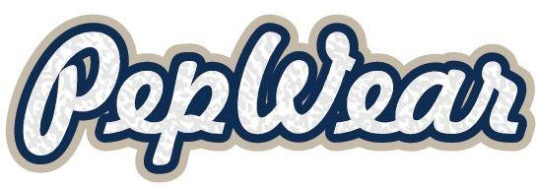 | Remember this achievement. Visit the PepWear Store or shop.lhsaa.org to purchase Official Event Merchandise including shirts and hoodies with participants’ names on the back, full color plaques, and more!  For assistance with orders contact (866) 775-3450 or customerservice@pepwear.com
Championship photographs | RomaPics is proud to be the official photographer of the Louisiana High School Athletic Association. Please stop by our booth during all of the  Allstate Sugar Bowl/LHSAA Championships to view and order photos. Team and individual, action, and all awards photos will be available for purchase and will be printed on site.  www.romapics.com
Championship rings | Congratulations champions! Celebrate your victory with your championship ring- the ultimate symbol of dedication, perseverance and teamwork. Herff Jones is proud to be the exclusive provider for LHSAA and LHSCA Championship Jewelry and is the recognized leader in celebrating student milestones.  Harris Beall, Clint Ivey, Donald Scamardo  Baton Rouge, LA // 225.927.1383 // gshhbrla@gradsupply.biz  Metairie, LA // 504.737.4439 // gradsupply@aol.com
Championship replica trophies | For more information regarding State Championship mini replica trophies and medals, contact  Gold Star Trophies at (225) 928-4230.  www.goldstartrophies.com
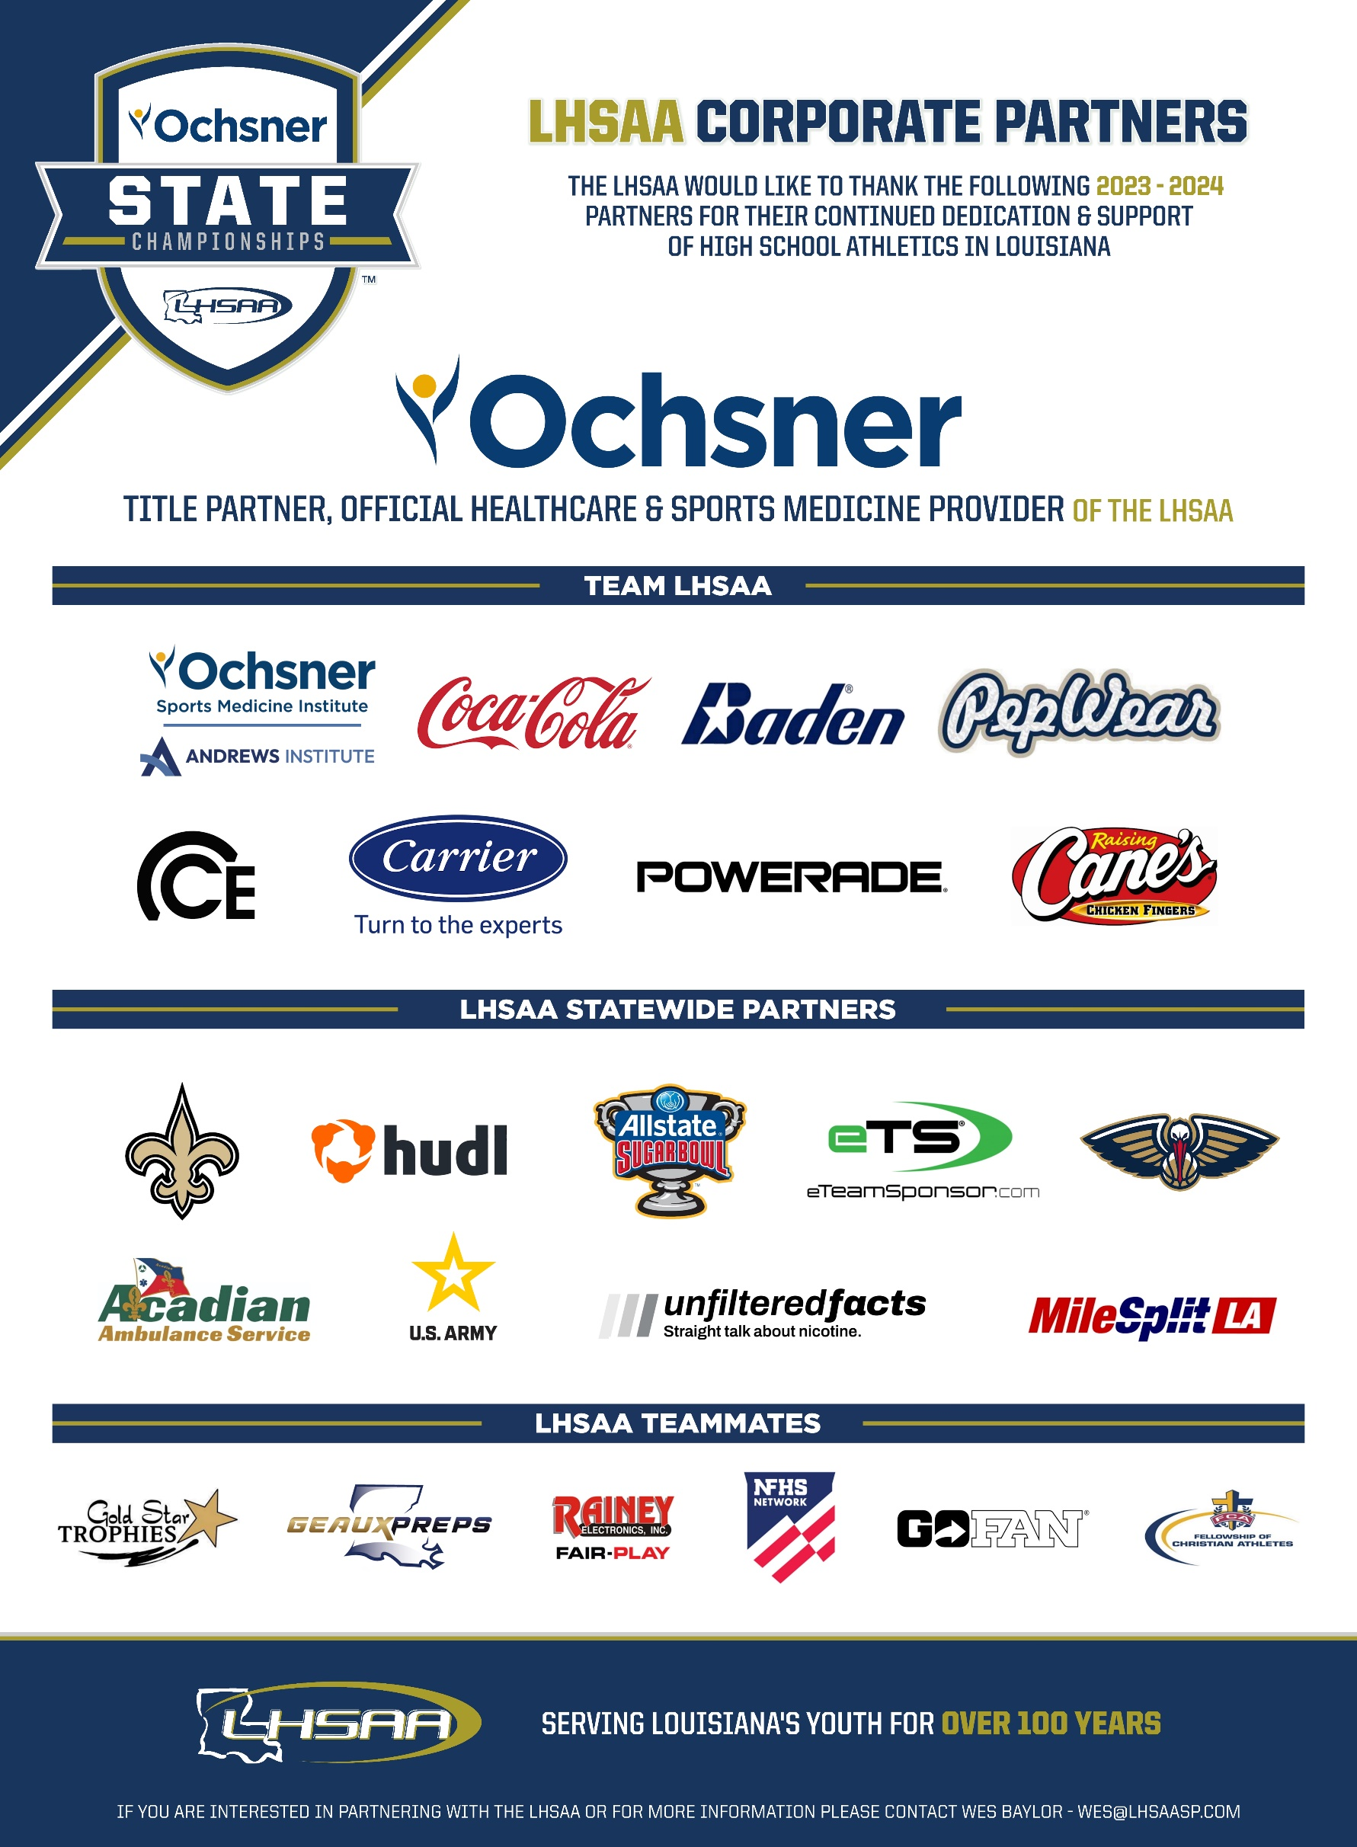

Powerlifting Quoted Hotel Rates
March 19-23, 2024

Hotel | Address | Contact | Contact Phone/Email | Rate Start | Rate End | Room Dates | Rooms
Comfort Inn & Suites- Scott | 1636 Saint Mary St. | Dean Ambelal | (337) 706-8128  cisla270@gmail.com | $114 | $134 | 3/19-3/24 | 15
Comfort Suites- Oil Center | 114 Rue Fernand | Aimee Broussard | (337) 456-8390  absales.comfortsuitesoilcenter@gmail.com | $124 | $134 | 3/19-3/24 | 25
Courtyard by Marriott Lafayette South | 200 Frem Boustany Dr. | Jessica McChesney | (337) 345-4450  jessica@sunrisehospitality.net | $119 | $119 | 3/19-3/24 | 12
DoubleTree by Hilton Lafayette | 1521 W. Pinhook Rd. | Jenny Korner | (337) 235-6111  jennifer.korner@hilton.com | $139 | $139 | 3/19-3/24 | 20
Hampton Inn & Suites | 1910 S. College Rd | Debi Fontenot | 337-266-5858  deborah.fontenot@hilton.com | $154 | $154 | 3/19-3/24 | 20
Hampton Inn Broussard | 2280 E. Main St. | Brittany Perry | (337) 330-2500  bperry@divihospitality.com | $129 | $129 | 3/19-3/24 | 45
Hilton Garden Inn-Lafayette Cajundome | 2350 W. Congress St. | Hilton Sales Team | (337) 291-1977  lftcd-salesadm@hilton.com | $139 | $159 | 3/19-3/24 | 50
Holiday Inn - Lafayette North | 2219 NW Evangeline Thrwy. | Christy Walter | (337) 541-2530  sales@lftlf.com | $99 | $99 | 3/19-3/24 | 25
Holiday Inn Express & Suites-Ambassador Caffery Pkwy. | 3903 Ambassador Caffery Pkwy. | Bridget Meade | (337) 981-0600  bmeade@jacaruso.com | $99 | $99 | 3/19-3/24 | 10
Home2 Suites by Hilton Parc Lafayette | 1909 Kaliste Saloom Rd. | Landon Vincent | (337) 706-8610  Landon.Vincent@Hilton.com | $159 | $209 | 3/19-3/24 | 30
Homewood Suites by Hilton Lafayette Airport | 201 Kaliste Saloom Rd. | Danielle Tassin | (337) 264-6044  Danielle.Tassin@Hilton.com | $139 | $139 | 3/19-3/24 | 20
Residence Inn by Marriott | 128 James Comeaux Rd. | Tara Boudreaux | (337) 232-3341  Tara.Boudreaux@marriott.com | $139 | $149 | 3/19-3/24 | 20
SpringHill Suites Lafayette South at River Ranch | 321 Settlers Trace Blvd. | Tyrone Bufkin | (337) 981-5512  TyroneB@lbaproperties.com | $151 | $151 | 3/19-3/24 | 15

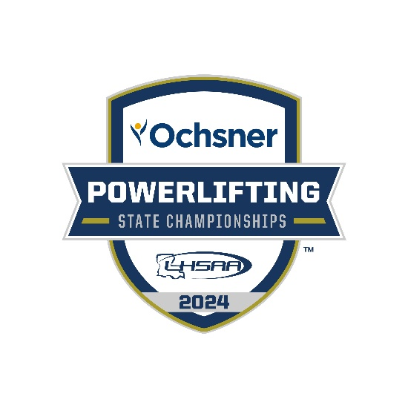

March 20-23, 2024

